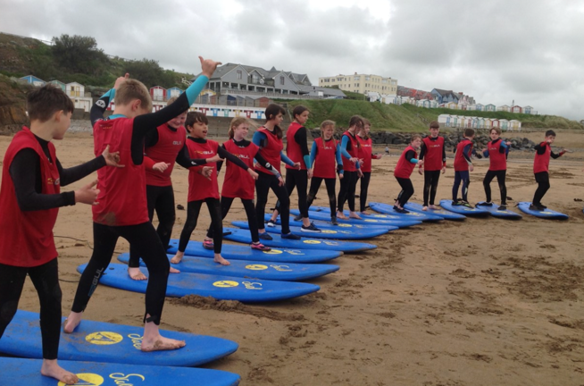
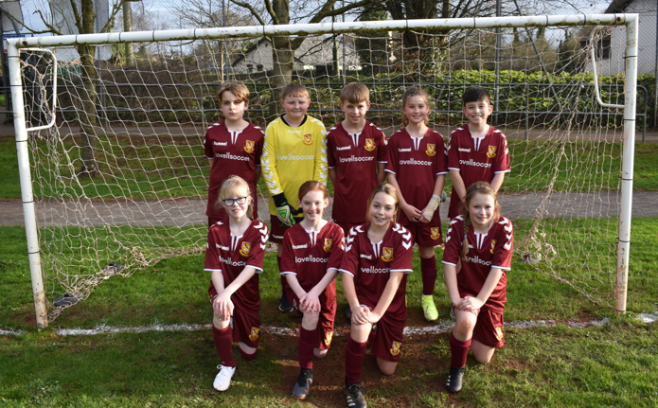
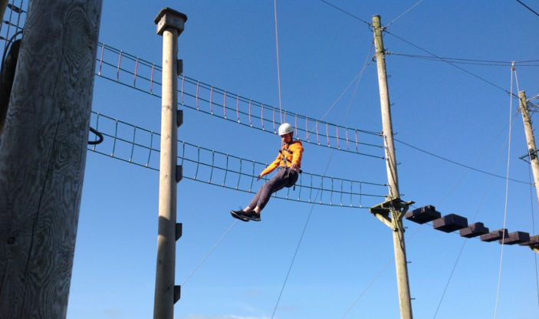

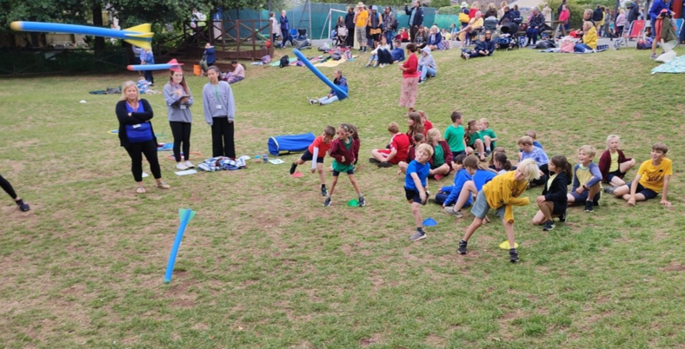
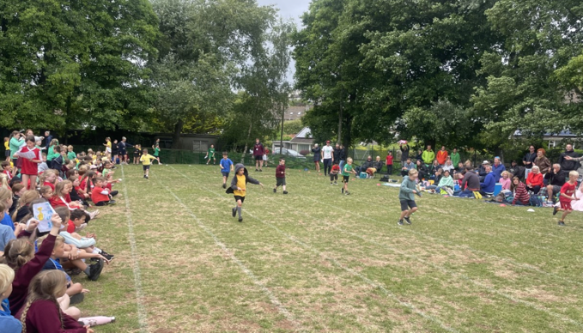
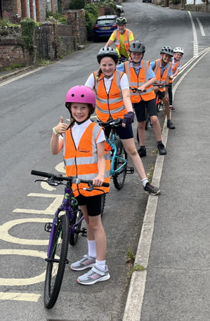

Primary Physical Education and Sport Premium Plan 2022 - 2023

Galmpton C of E Primary School
The following document is a working document to outline the intended expenditure of PPESP for the 2022 – 2023 academic year. Throughout the year, the actions completed will be evidenced and evaluated

Support for review and reflection - considering the 5 key indicators from DfE, what development needs are a priority for your setting and your students now and why? Use the space below to reflect on previous spend, identify current need and priorities for the future.

Key achievements to date: | Areas for further improvement and baseline evidence of need:
See Plan and Evaluation 2021/2022 for full overview:  - iPads have been purchased for use in lessons and teacher assessment.  - Most children have attended a sports festival in the year groups.  - Forest School set up has increased to include an outdoor classroom and further established grounds.  - Our Extra-curricular clubs offer increased.  - School teams have been developed, supported by new kits for pupils and staff. | The following are areas which we look to further develop in this academic year:  -Increase the daily exercise for pupils in line with health guidance (30 minutes daily)  - - Increase opportunities for every child in Key Stage 1 to have access to a free after school sports club  - - Improve opportunities for sport across lunchtimes.  - - Increase opportunities for pupils to participate in competitive sports.  - - Provide further professional development for staff through linking with a professional organisation  - - Increase swimming proficiency for pupils who are less confident  - - Develop improved assessment policy for PE with TU

Meeting national curriculum requirements for swimming and water safety | Please complete all of the below:
What percentage of your current Year 6 cohort swim competently, confidently and proficiently over a distance of at least 25 metres?  N.B. Even though your children may swim in another year please report on their attainment on leaving  primary school. | Will be updated in Summer 2023 following final assessment.
What percentage of your current Year 6 cohort use a range of strokes effectively [for example, front crawl, backstroke and breaststroke]? | Will be updated in Summer 2023 following final assessment.
What percentage of your current Year 6 cohort perform safe self-rescue in different water-based situations? | Will be updated in Summer 2023 following final assessment.
Schools can choose to use the Primary PE and Sport Premium to provide additional provision for swimming but this must be for activity over and above the national curriculum requirements. Have you used it in this way? | Yes – Additional swimming is funding in the Summer term for those assessed at needing further tuition and confidence.

Action Plan and Budget Tracking
Capture your intended annual spend against the 5 key indicators. Clarify the success criteria and evidence of impact that you intend to measure to evaluate for students today and for the future.

Academic Year: 2022/2023 |  | Total fund allocated: £17,760 | Date Updated: September 2022
Key indicator 1: The engagement of all pupils in regular physical activity – Chief Medical Officer guidelines recommend that primary school children undertake at least 30 minutes of physical activity a day in school  Key indicator 2: The profile of PESSPA being raised across the school as a tool for whole school improvement  Key indicator 3: Increased confidence, knowledge and skills of all staff in teaching PE and sport  Key indicator 4: Broader experience of a range of sports and activities offered to all pupils  Key indicator 5: Increased participation in competitive sport |  |  |  |  | Percentage of total allocation:
 |  |  |  |  | %100 Planned for
School focus with clarity on intended impact on pupils: | K.I | Actions to achieve: | Funding allocated: | Evidence and impact:  Ongoing update: Next Update in Nov 2022 | Sustainability and suggested next steps:
Pay for Sports Specialists (Torquay United)  Increase the opportunities for pupils to participate in competitive activities across a broad range of sports – whilst increasing staff confidence. | 2  3  4  5 | - All classes to attend a minimum of x1 sports festival a year.  - Pupils to compete against other schools in team groups e.g. A, B, C teams.  - Pupils to attend festivals which offer a range of sporting activities – promoting a love for sport.  - Arrange a PE professional development meeting for staff (Torquay United).  - Arrange Play leader training for Yr 5/6 pupils.  - Arrange training sessions for our competitive sports teams from Torquay United.  - Identify needs of staff support required – area of PE with less confidence.  - Torquay United to work alongside staff delivering weekly PE lessons for all classes.  - Work with professional to create medium term plan for staff members – e.g., co-teaching parts of the lesson.  - Assess impact on staff through the delivery of PE through use of assessment strategy for PE.  - Arrange for Torquay United to organise clubs during lunch time to promote participation in sport. | Planned  £14,000
Increase pupils’ offer to experience a range of sporting activities through ‘Outdoor Learning’. Support mental and physical well-being of pupils. | 1  2  3  4 | - All children will have the opportunity to participate in a range of challenging, progressive and creative outdoor learning experiences.  - We will embed outdoor learning in the curriculum so that learning in the outdoor environment becomes a reality for all our children. Organise and coordinate games for all children alongside the PE leaders at break and lunch time.  - Ensure curriculum coverage across the school showing progress and skill building.  - Timetable every class in KS2 across the school to experience Forest School throughout the year.  - Develop long term plan which incorporates the school’s progression of metacognition. | Planned expenditure  £500 –
Additional swimming tuition  Provide transport and tuition to extend confident and least confident swimmers in order to meet KS2 expected standards. | 2 | Actions for the summer term 2023  - Following Yr 3-6 completing statutory swimming by Spring 2, identify pupils requiring additional support.  - Identify pupils who are exceeding for specific coaching from gala competitions.  - Plan for provision that is bespoke for the needs of individual swimmers. | Planned Expenditure  £1000
Increase KS1 participation in extra-curricular clubs through an offer which is free for families. | 1  2  5 | - Arrange for a minimum of x1 free sports clubs aimed at KS1 pupils.  - Create a system where pupils can rotate through the year to reach maximum opportunities for all. | Planned Expenditure  KS1 Sports Club  £500
Provide appropriate equipment for staff to plan with so all pupils to be engaged and a range to provide a variety of experiences.  Replenishment of/new equipment | 1  2  4  5 | - Complete school inventory of equipment in the school  - Identify needs for further equipment required  - Order equipment to ensure suitable equipment in place for extracurricular clubs and curriculum PE | Planned Expenditure  £1660

