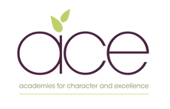
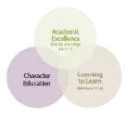
Galmpton C of E Primary Long Term Planner whole school 2025/2026

Autumn 1 |  |  | Autumn 2 |  |  | Spring 1 |  |  | Spring 2 |  |  |  | Summer 1 |  |  | Summer 2
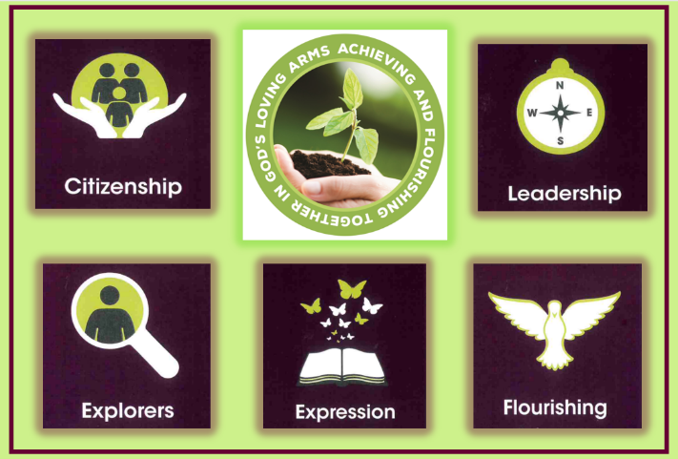  Citizenship |  |  |   Exploration |  |  |   Leadership |  |  |   Expression |  |  |  | 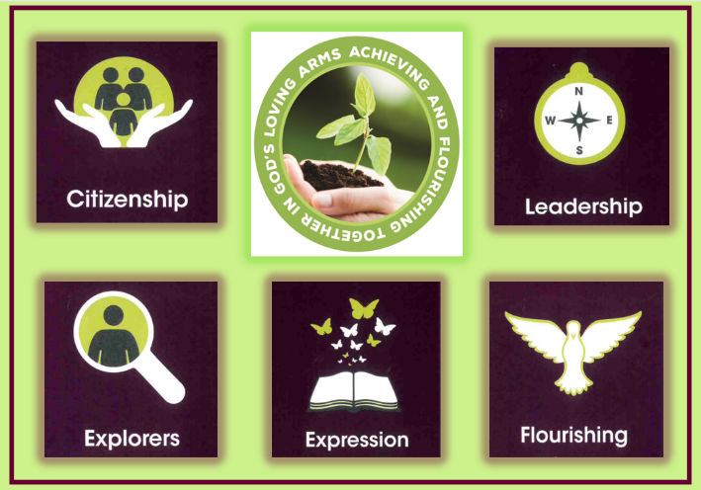  Flourishing |  |  |   Citizenship
Year group and Whole school Learning Experiences
Metacognitive strand  Independence |  |  | Metacognitive strand  Creativity |  |  | Metacognitive strand  Collaboration |  |  | Metacognitive strand  Independence |  |  |  | Metacognitive strand  Creativity |  |  | Metacognitive strand  Collaboration
Whole school enquiry-Autumn1  Why is Legacy Important?  7 weeks |  |  | Whole school enquiry-Autumn 2  What will my gifts be this Christmas?  7 weeks |  |  | Whole school enquiry-Spring 1-  - What does a diverse Community look like?  - How am I achieving and flourishing? (assessment midpoint review)  5.4 weeks |  |  | Whole school enquiries  Spring 2-  - How is land used by the local community?  - Why is Easter so important for Christians?  5.4 weeks |  |  |  | Whole school enquiries  Summer 1- What is my role in this changing world?  4.5 weeks |  |  | Whole school enquiries  Summer 2-  - How can I best serve my community?  - What does it mean to grow and change?  7 weeks
Art? | Geography | History | Science | Narrative | DT | PSHE | Science | Self review  days  Self assessment and conferencing days-my report | Geography | Art |  | RWE | Science |  | History | Narrative | RSE |  | Self review  days  Self assessment and conferencing days-my report | DT
Agatha’s stained-glass window – Churston | Why do people come to Torbay on holiday? -Local study | How did the development of the Railway impact the community? | Food chains  Why do carnivores need plants to survive? | Christmas writing | Making something with a purpose | Difference and diversity | Habitats –  How plants and animals co exist |  | Cities and the UK-using maps | Open gardens, florals-engaging with the local community through art |  | The Easter story  (2 days) | Animals including habitats |  | The great fire of London -a changing world with changing events | Class choice | My body |  |  | Cooking-serving my community through a food learning experience
Outcome and key dates
- 19th September – whole school Agatha Christie exhibition/festival  - Holiday brochure –‘Come to Torbay’  - DT product |  |  | - Science information text  - 17th December -Christmas gift/art gallery for the community, class workshops and artist talks  - Christmas writing  - Christmas service/nativity WB 9th December |  |  | - whole school book our beautiful diverse world?  - Science explanatory text illustrated  - Mid year report card written by pupils – 12th/13th February |  |  | - Infographic page detailing countries of the UK  - Completed pieces prepared for open gardens  - Easter service -performance/service  for the community - 2nd April |  |  |  | - Open gardens event, tour guides and art -7th June exhibition for community  - Class book detailing the GFOL events |  |  | - Extended written piece of writing  - Labelled body map  - Completed end of year report- 29th/30th June  - Contribution to a local community food/cooking event.WB 13th July
Writing Genre
Reflective Writing | Brochure writing/  persuasive | Biography | Report | narrative | Information | Poetry | Explanatory writing |  | Non chron report |  | Descriptive | Story | Report | Fictional writing |  | Story writing/  adventure | Labelling | Reflective writing |  |  | Instructions
Teaching of Other Subjects

Religion and Worldviews – a core subject also taught weekly Music- weekly lessons using the Kapow programme MFL-weekly lessons using the PLN Spanish Programme
PE/Games including swimming in KS2 taught weekly

