RECEPTION TERMLY OVERVIEW – AUTUMN 1
 | Communication and Language | Physical Development | Personal, Social and Emotional Development | Literacy | Mathematics | Understanding of the World | Expressive Arts and Design | Linked Texts
What makes me special?  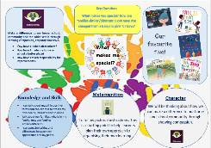  How can I keep myself healthy?  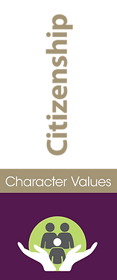  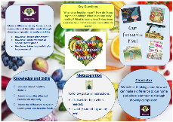 | Enjoy listening to longer stories and can remember much of what happens.  I can start a conversation with an adult or a friend and continue it for many turns.  I know how to listen carefully and why listening is important. | I can start and stop  I can run fast and slow  I can draw freely  I know how to hold a paint brush  I can move and rotate my lower arms and wrists independently | I am confident to try new activities  I can make good behavioural choices  I know what a family is  I can make healthy food choices  I can brush my teeth accurately  I know the names of some feelings  I know how to associate feelings with words  I know what a friend is  I know how to be kind to others | I know some familiar stories and poems  I know the meaning of some vocabulary linked to stories  I know that graphemes represent phonemes  I know my marks have meanings to others  I can develop phonological awareness to: spot rhymes in familiar stories and poems, count or clap syllables in a word, recognise words with the same initial sound. | identify when a set can be subitised and when counting is needed  subitise different arrangements, both unstructured and structured, including using the Hungarian number frame  make different arrangements of numbers within 5 and talk about what they can see, to develop their conceptual subitising skills  spot smaller numbers ‘hiding’ inside larger numbers  connect quantities and numbers to finger patterns and explore different ways of representing numbers on their fingers | I know daily weather patterns  I can say what I see in a picture  I know people who are important to me  I know I have changed over time  I know some simple features of my immediate environment | I know the effects of mark making  I know the names of colours  I can use a variety of tools to make marks  I can sing a range of well-known nursery rhymes and songs  I can say how a piece of music makes me feel  I know the difference between loud and quiet  I know how to stick and glue | 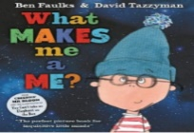  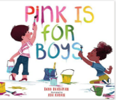  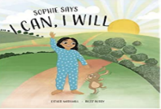  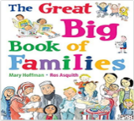  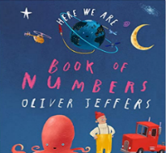

RECEPTION TERMLY OVERVIEW – AUTUMN 2
 | Communication and Language | Physical Development | Personal, Social and Emotional Development | Literacy | Mathematics | Understanding of the World | Expressive Arts and Design | Linked Texts
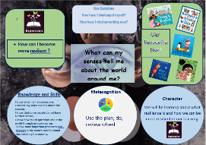  What can my senses tell me about the world around me?  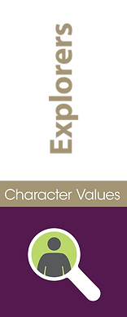  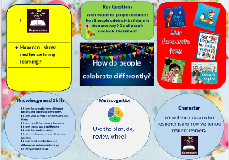  How do people celebrate differently? | I can actively show good listening skills.  I can confidently use newly acquired vocabulary.  I can communicate in full sentences. | I know the importance of holding my pencil correctly.  I know how to run and change direction  I know how to run in a straight line  I can move and use my hands and fingers without moving my shoulders. | I can see myself as a valuable individual  I can build good relationships  I can manage my own personal hygiene | I know how to write my name  I can link some sounds to letters  I know some digraphs  I can begin to blend sounds into words to read short words made up of known letter- sound correspondences.  I can understand what has been read to me and anticipate key events. | hear and join in with the counting sequence, and connect this to the ‘staircase’ pattern of the counting numbers, seeing that each number is made of one more than the previous number  develop counting skills and knowledge, including: that the last number in the count tells us ‘how many’ (cardinality); to be accurate in counting, each thing must be counted once and once only and in any order; the need for 1:1 correspondence; understanding that anything can be counted, including actions and sounds  compare sets of objects by matching  begin to develop the language of ‘whole’ when talking about objects which have parts | I know places can be different  I know the world is round  I know environments vary from one another  I know how to ask questions about the world through using my senses - feeling, hearing, seeing  I can say how two pictures are different  I can identify similarities and differences  I know that people have different beliefs and celebrate special times in different ways  I know the 4 seasons | I know how to use tools including hands and fingers to apply paint  I know how to hold and use pencils  I know how to combine materials  I know the effect of cutting materials  I can bring narrative into my play  I know the difference between singing and speaking | 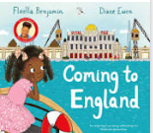  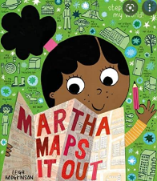  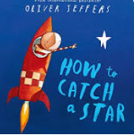  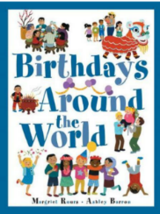  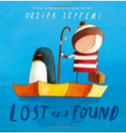

RECEPTION TERMLY OVERVIEW – SPRING 1
 | Communication and Language | Physical Development | Personal, Social and Emotional Development | Literacy | Mathematics | Understanding of the World | Expressive Arts and Design | Linked Texts
Why are memories important?  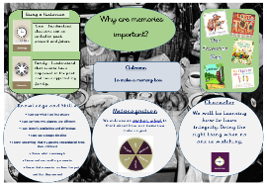  How can we build the perfect shelter?  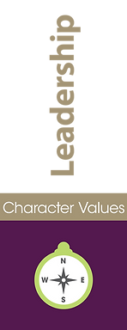  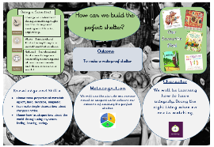 | I know what a question is.  I know how to answer who, where and when questions.  I know a range of connectives I can use to extend my sentences. | I can show some control of apparatus  I can make a simple throw  I can attempt a catch  I can use a pencil effectively to form letters  I know how to hold a pair of scissors  I can jump in different ways | I know how to work well with someone else  I know how to take turns  I know what familiar means  I know not to go with someone who isn’t familiar | I know what a character is  I know that text is read from left to right  I know some common exception words  I know how to form lower case letters  I can segment words to write them | continue to develop their subitising skills for numbers within and beyond 5, and increasingly connect quantities to numerals  begin to identify missing parts for numbers within 5  explore the structure of the numbers 6 and 7 as ‘5 and a bit’ and connect this to finger patterns and the Hungarian number frame  focus on equal and unequal groups when comparing numbers | I can use a simple timeline  I know the past has happened  I know what a day is  I know the present is now  I know that the future hasn’t happened  I know something that my parents remembered from their childhood  I know what a memory is  I know and can recall my memories  I know that memories are from the past and that they are real  I know some important processes and changes in the natural world around me, including changing states of matter  I can make simple observations about changes I notice  I know some properties of materials eg soft, hard, bendable, magnetic | I know how the importance of plan, do and review  I can draw with increasing complexity and accuracy  I can create with a purpose in mind  I can develop storylines into my play  I know different materials make different sounds  I know how to stay safe when constructing | 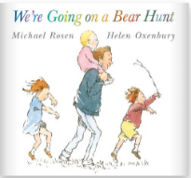  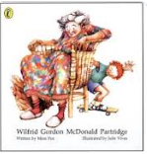  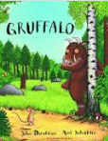  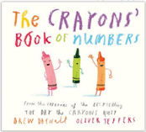  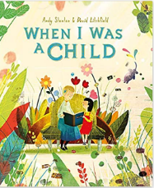

RECEPTION TERMLY OVERVIEW – SPRING 2
 | Communication and Language | Physical Development | Personal, Social and Emotional Development | Literacy | Mathematics | Understanding of the World | Expressive Arts and Design | Linked Texts
What signs of new life can I see?  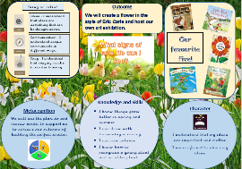  Is the big bad wolf really bad?  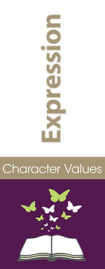  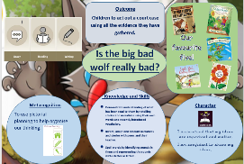 | I know how to add interesting detail to my sentences  I can connect ideas or actions using a range of connectives. | I know how to take off and land when jumping  I know how to roll, jump and perform a simple balance  I know how to move in time to a piece of music  I can use scissors effectively. | I know what a healthy relationship looks like  I can recognise feelings in myself and have strategies to help me. | I know what a setting is  I know I need to listen attentively to answer questions about a story  I know words are demarcated with spaces  Begin and end their sentences (orally before writing) | understand that two equal groups can be called a ‘double’ and connect this to finger patterns  sort odd and even numbers according to their ‘shape’  continue to develop their understanding of the counting sequence and link cardinality and ordinality through the ‘staircase’ pattern  order numbers and play track games  join in with verbal counts beyond 20, hearing the repeated pattern within the counting numbers | I know if something is alive or dead  I know how to care for something living  I know how to recognise a young plant and an older plant  I know I need to respect and care for the natural environment, animals and all living things  I know how seeds and bulbs grow into plants.  I know things grow better in spring and summer  I know summer is hot and winter is cold  I know how to keep warm and stay cool | I know how to mix colours  I can retell a story  I can hear a rhythm in a song or rhyme  I can move my body in time to the music | 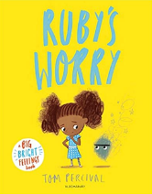  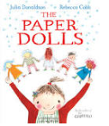  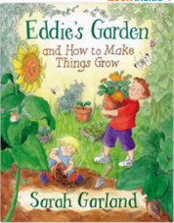  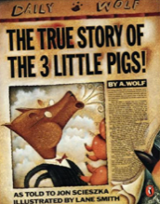  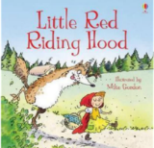
RECEPTION TERMLY OVERVIEW – SUMMER 1
 | Communication and Language | Physical Development | Personal, Social and Emotional Development | Literacy | Mathematics | Understanding of the World | Expressive Arts and Design | Linked Texts
Where can my wellies take me?  How do minibeasts help us?  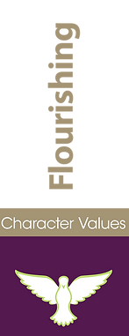  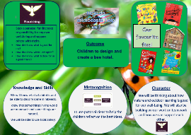 | I can ask questions for clarification  I can retell familiar stories, songs or rhymes  I know a range of rhymes, poems and songs by heart | I know how to throw something with a bent arm  I know how to speed up my movements or slow down  I know how to start a race  I know to bend my knees when I land from a jump  I can use a range of small tools | I can show resilience and perseverance when faced with a challenge. | I can read simple sentences containing known letter-sound correspondences.  I know how to construct a sentence orally  I can consider who I am writing for eg writing a note or labelling a picture for family/school  To write some irregular common words | continue to develop their counting skills, counting larger sets as well as counting actions and sounds  explore a range of representations of numbers, including the 10-frame, and see how doubles can be arranged in a 10-frame  compare quantities and numbers, including sets of objects which have different attributes  continue to develop a sense of magnitude, e.g. knowing that 8 is quite a lot more than 2, but 4 is only a little bit more than 2 | I know the location my school is situated in  I know some important places where I live  I know what a map is and why we use them  I can identify similarities and differences between environments  I can talk about people I have come across in my community  I can communicate my findings  I can draw information from a simple map  I can use aerial maps and photos to comment on simple features I can draw a simple map  I can use simple symbols to identify features on a map  I know about similarities and differences between places eg countryside and town  I know some facts about animals through observations. | I can explain how I made something  I can Perform songs, rhymes, poems and stories with others, and – when appropriate try to move in time with music  I can suggest how I might make something | 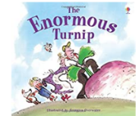  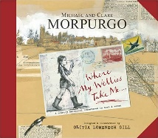  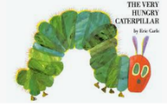  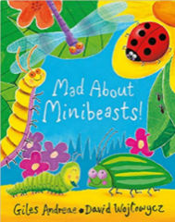  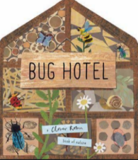  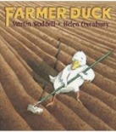

RECEPTION TERMLY OVERVIEW – SUMMER 2
 | Communication and Language | Physical Development | Personal, Social and Emotional Development | Literacy | Mathematics | Understanding of the World | Expressive Arts and Design | Linked Texts
How did Grace Darling show compassion for others?  How can we show compassion for our blue planet?  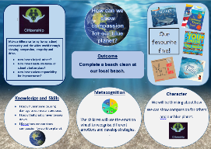 | I can use talk to organise thinking and solve problems  I know how to answer why and how do you know questions | I know how to hold a knife and fork  I can perform simple dance moves  I know how to throw with some accuracy by aiming at a target | I can consider the feelings of others.  I can set myself personal challenges. | I know how to form some capital letters  I can express my ideas and feelings about my experiences using full sentences | begin to generalise about ‘one more than’ and ‘one less than’ numbers within 10  continue to identify when sets can be subitised and when counting is necessary  develop conceptual subitising skills including when using a rekenrek | I know we need sunlight to create a shadow  I can make simple observations about changes I notice  I know that humans can have a positive and negative impact on our world | I can create sounds using a variety of methods  I can create some sounds with a group of people  I know that music can affect the way I feel | 