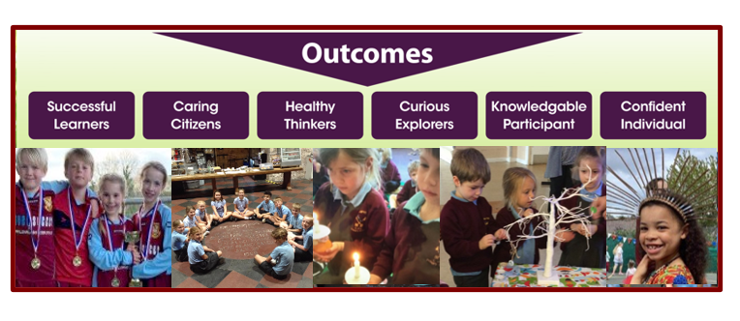

**Community Partnerships**

Open gardens joint village art project-**Summer 2**

Card making art Project at the Railway -**Summer 2**

**Cross Trust and other school events**

ACE Olympics **– Summer 2**

Sports day- **Summer 2**

ACE music event- **Summer 2**

**Church and mission community Projects**

Joint Parish/school service-**Summer 2**

Harvest Brixham food bank appeal **Autumn 1**

Shoe Box appeal – **Autumn 2** Christmas carol singing/church services

**Character Education Opportunities**

Christmas Fayre young apprentice project -**Autumn 2**

Summer fayre fund raising class project – **Summer 2**

Shared community World Book day **event-Spring 2**

**Diversity**

RSHE - Racism and antibullying -key note speaker **Autumn 1**

Twisted tales outcome -presentation to parents-**Spring 2**

**Personal Development and Enrichment Opportunities Year 5**

**Keeping Safe**

RSHE Homophobia project Pansy Planting – **Autumn 1**

Fire Safety Talk -**Spring 1**

First Aid day course-

**Summer 2**

**Visitors and Expert Leads**

Open the Book drama workshops with Chris G-**fortnightly**

Spanish workshops with Churston – **Spring 1/2**

**Visits and Trips**

Space Dome- **Autumn 2**  Brixham Science extravaganza -**Spring 1**

Musical performance Churston-**Summer 2**

Eden Project **Summer 2**