Computer Code of Conduct at Galmpton:

- I promise to use all technology tools in a responsible and careful manner. I will not damage hardware and software or change any settings without adult permission.
- I promise to use technology tools and the Internet at school for schoolwork only. I will only use the programs, websites, applications and databases that my teacher has approved.
- I promise not to share my passwords with anyone other than my teacher; I will not use another student’s password to access his/her account for any reason.
- I promise to use technology tools to interact with others appropriately. I will not use technology tools to tease, harass, frighten, or bully anyone.
- I promise not download, view, send, or display inappropriate pictures or messages.
- I promise not use technology tools to play online games that have not been approved by my teacher.
- I promise not give out personal information about me or others (such as name, address, or telephone number) on the Internet.
- I promise to obey the copyright laws and not take credit for someone else’s work.
- I promise to promptly tell an adult if I see or read something that is inappropriate, dangerous, threatening, or makes me feel uncomfortable.
- I understand that my work on the computer is not private and that use of the computer and Internet at the Belgrade School District is a privilege, not a right.

This code has been explained to me by: ___________________________

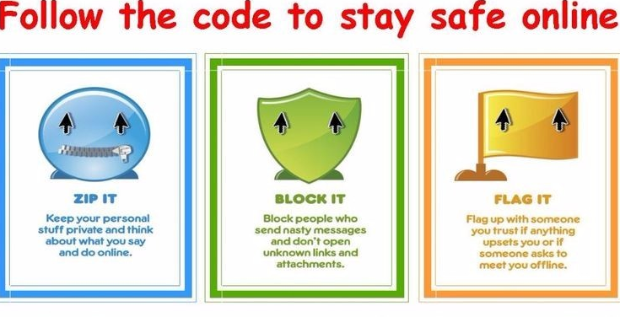
I agree to the Code of Conduct above

Signed_____________________________
Date: ______________________________

