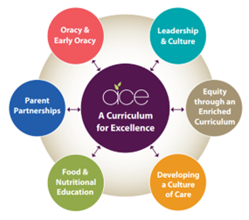
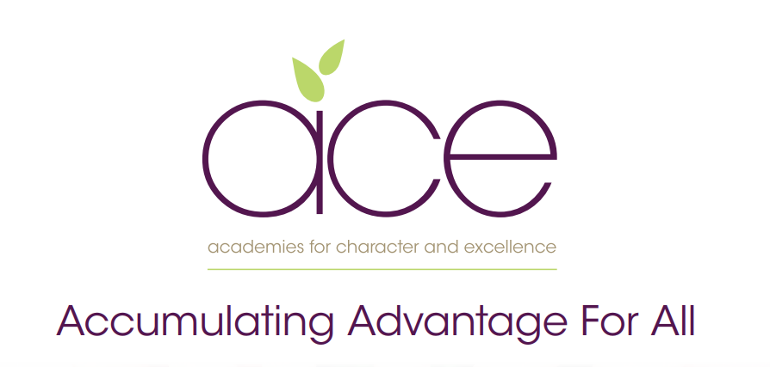

Galmpton Church of England school Pupil premium strategy statement
2022–2023

This statement details our school’s use of pupil premium (and recovery premium for the 2021 to 2022 academic year) funding to help improve the attainment of our disadvantaged pupils.
It outlines our pupil premium strategy, how we intend to spend the funding in this academic year and the effect that last year’s spending of pupil premium had within our school.

School overview

Detail | Data
School name | Galmpton C of E Primary
Number of pupils in school | 222
Proportion (%) of pupil premium eligible pupils | 14%
Academic year/years that our current pupil premium strategy plan covers (3 year plans are recommended) | 2021–2024
Date this statement was published | October 2023
Date on which it will be reviewed | November 2023
Statement authorised by | Governing body
Pupil premium lead | Tim Rutherford
Governor / Trustee lead | Katy Burns,

Funding overview

Detail |  | Amount
Pupil premium funding allocation this academic year | £41,790
Recovery premium funding allocation this academic year | £1015
Pupil premium funding carried forward from previous years (enter £0 if not applicable) | -
Total budget for this academic year  If your school is an academy in a trust that pools this funding, state the amount available to your school this academic year | £42805

Part A: Pupil premium strategy plan

- See our Trust wide plan ‘Accumulating Advantage for all’
In a changing world we recognise the need to ensure that our Curriculum reflects how pupils are supported and encouraged to flourish in all aspects of their lives. Current research shows that the South West is one of the most challenging areas to grow up poor. We strongly believe that as a Trust, and through our Curriculum, we are able to narrow the disadvantaged gap, supporting all pupils.

Our aims for our disadvantaged pupils

- Our aim as a Trust is to ensure that all pupils accumulate advantage based on the high quality experience that we offer them through our Curriculum and enquiry based approach to learning.

- Our Curriculum is rich and ambitious and offers all pupils an equal opportunity to experience a range of outdoor lessons, take part in educational visits, theatre trips, hands-on days, expert visits and have the opportunity to explore a wide range of extra-curricular clubs.

- We believe that all pupils should have the opportunity to aspire to be the best version of themselves, therefore we provide pupils with the experiences that develop their love of learning and support them to acquire experiences as they move through their school lives, to make informed choices when deciding future decisions.

Statement of Intent

At the heart of our curriculum lie three core values: pursuit of academic excellence; the explicit teaching of learning to learn, which includes the development of metacognition; and crucially, character education. We believe that through our curriculum and core principles we can ensure that our very high expectations result in improved outcomes for disadvantaged pupils. This ensures all children will achieve and flourish whilst acquiring life longs skills that enable learners to overcome any barriers to learning and future successes.

Objectives for our disadvantaged Pupils

- We will ensure that the progress of our disadvantaged children will equal or exceed those who are not disadvantaged by implementing our strategy plan. The ACE curriculum plays a central and critical role in accumulating advantage for all pupils, including those that are presently or previously experiencing disadvantage.

- All disadvantaged pupils will be equipped, academically, socially, culturally and emotionally to continue to make progress at their Secondary schools and beyond. Our aim is to ensure that all children leaving our schools are successful learners, curious explorers and healthy thinkers.

Our current pupil premium plan focuses on the following goals (see ‘Accumulating advantage for all’ booklet for more detail)

Strong Leadership that drives:
- Equity through an enriched curriculum (including high quality, well researched and impactful interventions)
- A culture of high quality care
- Food and Nutritional Education
- Effective parent/carer partnerships
- Development of Early Oracy and ongoing oracy skills

Challenges

This details the key challenges to achievement that we have identified among our disadvantaged pupils.
Challenge number | Detail of challenge
1 | 50% of our disadvantaged children have poorer oracy skills on entry, including limited vocabulary, affecting their spoken language, comprehension and, later, their reading and writing skills. This also hampers accessing wider knowledge.
2 | 46% of children on our disadvantaged register, their social, emotional and mental health (SEMH) needs negatively affect their learning.
3 | 30% of children lack resilience for learning and have more limited opportunities for learning outside of school.
4 | Children joining the school (18% at Spring 2) and not having the benefits of being with us for longer periods of time eg in 2019 4/7 pupils were not in the school in KS1
5 | For 37% of all disadvantaged pupils, mathematical concepts and reasoning skills are not as well developed as reading skills, poor mathematical fluency impacts on their ability to calculate, reason and problem solve.
6 | 25% of children on the register are our most vulnerable disadvantaged pupils have had previous trauma in their lives and this continues to impact on their lives.

Intended outcomes - see ‘Accumulating Advantage for all’

Intended outcome | Success criteria
- A Curriculum for Excellence  The ACE curriculum is ensuring QFT is making a difference for our disadvantaged pupils and progress measures show the gap between disadvantaged and others is closing | - As a result of careful and focused monitoring our PP pupils are becoming successful learners  - Journals reflect progress made in all three areas- metacognition, character education and academic excellence (see individual PP tracker)  - The progress of disadvantaged pupils is at least the same as the  - progress of non-disadvantaged pupils and no greater than a 10% difference
- Oracy  All disadvantaged pupils have improved oracy skills and are increasingly able to communicate effectively | - Language link programme demonstrates improved language skills  - Oracy approach (across the curriculum) is evident in terms of key outcomes for pupils  - Mathematical talk (PDM 3.10.22) and maths leader coaching sessions have clear impact on outcomes  - PP children are read with daily, prioritised by class teachers and TA’s. - Pre-teach of vocabulary is introduced to children and explained prior to provide more opportunities for children to be successful. - Vocabulary is explicitly taught through quality first teaching and is planned for by class teachers. All classes regularly using the ‘remote control’ cards’
- Enrichment opportunities are providing pupils with the skills and knowledge to become more successful learners | - Take up of ASCs is high and pupils are clearly gaining through these experiences  - All disadvantaged pupils attend residentials
- High quality care through SEMH support is ensuring excellent wellbeing and readiness for learning | - Pupil outcomes have improved in all areas (academically, socially, emotionally, culturally)  - Pastoral support is well matched to individual need
- Food and Nutrition  Pupils and families have opportunities in school to participate in workshops and clubs to improve health through food and nutrition education | - All PP children are given opportunity to attend cookery club  - Families invited to a ‘family bake’ session to celebrate the course and grow the club  - PP children are well fed in school, they have good access to food and being hungry is never an issue – nurture group leads to monitor and check in
- Parent/carer partnerships are strong and parents are increasingly able to support their children’s well being and learning | - Improve attendance of disadvantaged pupils to 95%

Activity in this academic year

Teaching (for example, CPD, recruitment and retention)

Budgeted cost: £20, 800

Activity | Evidence that supports this approach | Challenge number(s) addressed
- Use of language link and other oracy strategies to develop communication skills in the Early Years and KS1 | Early Reading framework – Section 2: developing Talk and Appendix 2  EEF – Oral Language Interventions | 1,4
- Deliver impactful and bespoke nurture sessions that allow pupils to develop strategies around social skills, self regulation and self expression | EEF social and emotional learning  https://educationendowmentfoundation.org.uk/education-evidence/evidence-reviews/social-and-emotional-learning | 2
- Provide extended opportunities for pupils, ensuring all disadvantaged pupils have wider opportunites to take part in art, sports, music clubs | EEF social and emotional learning  https://educationendowmentfoundation.org.uk/education-evidence/evidence-reviews/social-and-emotional-learning | 3
- Continue to maintain standards in reading though our whole school reading approach  Smaller phonics groups for targeted RWI support. | EEF- Targeted Academic Support  EEF - Early Reading framework – Section 2: developing Talk and Appendix 2  https://educationendowmentfoundation.org.uk/education-evidence/evidence-reviews/reading-programmes  Implementing a systematic programme (ERF) Early Reading Framework – Section 5: Building a team of experts | 4
- Deliver pre teaching session and mathematical interventions to close gaps for lower attaining children | EEF -https://educationendowmentfoundation.org.uk/education-evidence/evidence-reviews/early-years-and-key-stage-1-mathematics-teaching | 5
- Develop wellbeing for pupils through the ‘one goal’ programme to ensure good mental health for all  Continue to provide pastoral/mental health support through the beach room club and afternoon nurture session | EEF – Embedding Formative Assessment  EEF – Metacognition  EEF- https://educationendowmentfoundation.org.uk/education-evidence/evidence-reviews/behaviour | 6

Targeted academic support (for example, tutoring, one-to-one support structured interventions)

Budgeted cost: £10,505

Activity | Evidence that supports this approach | Challenge number(s) addressed
1:1 phonics tutoring -Read, write Inc | EEF – one to one tutoring | 1,2
Additional reading support (including Fresh start -1 to 1) | Early Reading Framework – Section 5: Building a team of experts | 2
1:1 fluency intervention -Language link | EEF – improving literacy at KS2 | 2
Targeted support plans for individual PP pupils delivered by support staff. | EEF – Follow the Asses, Plan, Do, Review process | 1,2,3
Teachers prioritise pre-teaching in writing for most disadvantaged pupils (vocabulary checks, gathering ideas, plans for writing) | EEF – one to one tutoring | 1,2

Wider strategies (for example, related to attendance, behaviour, wellbeing)
Budgeted cost - £11,500

Activity | Evidence that supports this approach | Challenge number(s) addressed
SENDco/Nurture support to support disadvantaged families with  Parenting advice, individual pupil support and referrals for escalated support . | EEF – parental engagement | 4,5,6
Nurture clubs provision and support for CFC pupils to ensure bespoke interventions and programmes for individual pupils | EEF – behaviour interventions | 3,4,6
Breakfast club runs daily for most disadvantaged for time to talk and regulation time. | EEF – Magic Breakfast Club | 4,6
Parental engagement – ASC provision and additional support packages | EEF – parental engagement | 5,6
SENDco/Nurture support to support disadvantaged families with  Parenting advice, individual pupil support and referrals for escalated support . | EEF – parental engagement | 4,5,6

Total budgeted cost: £42,805

Part B: Review of outcomes in the previous academic year

Findings relating to our disadvantaged pupils were as follows:

2021/2022 Whole school outcomes for Disadvantaged pupils
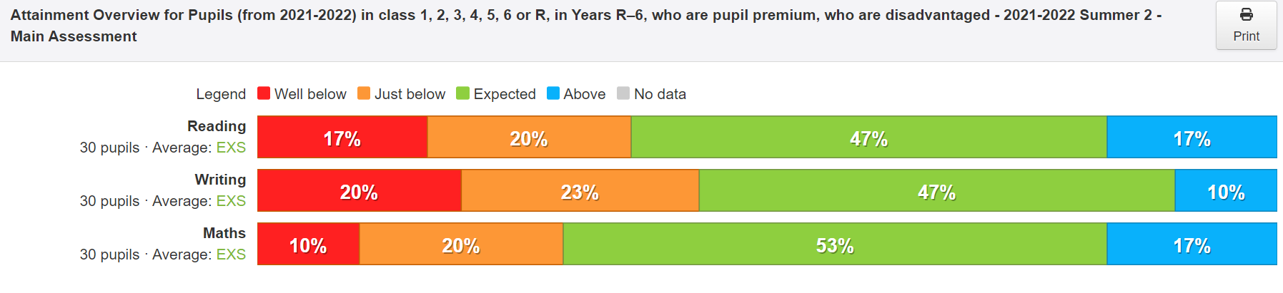

2021/2022 outcomes for by year group
EYFS
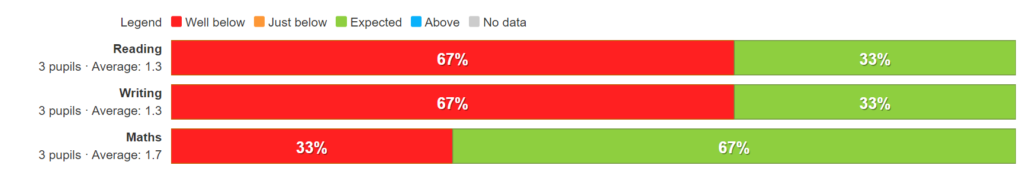
Y1
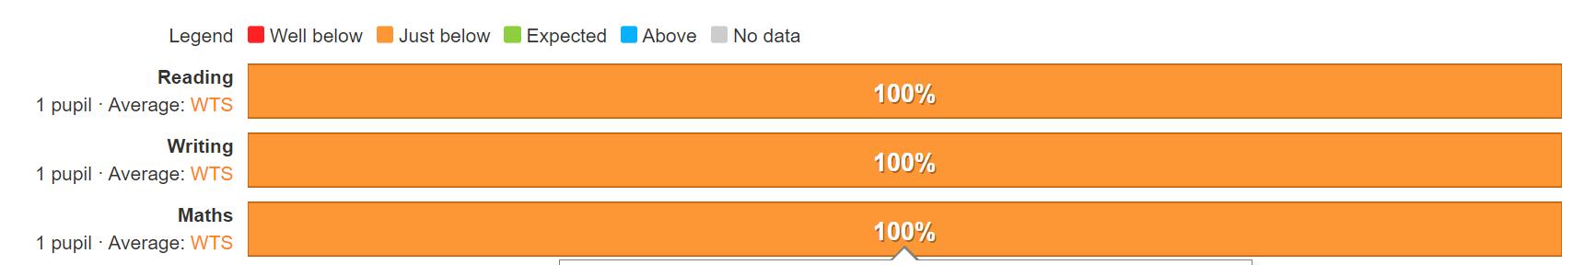

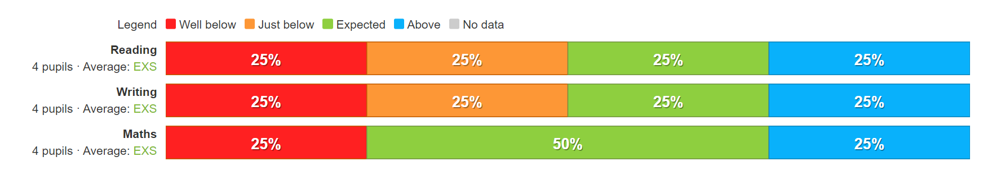
Y2

Y3
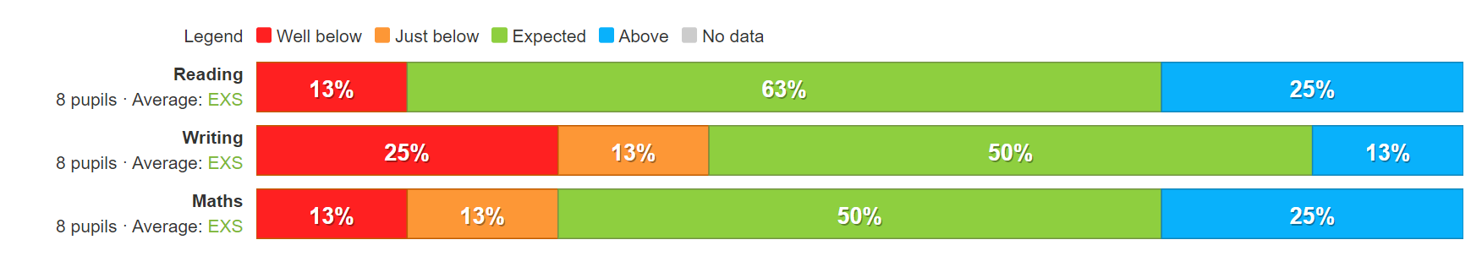
Y4
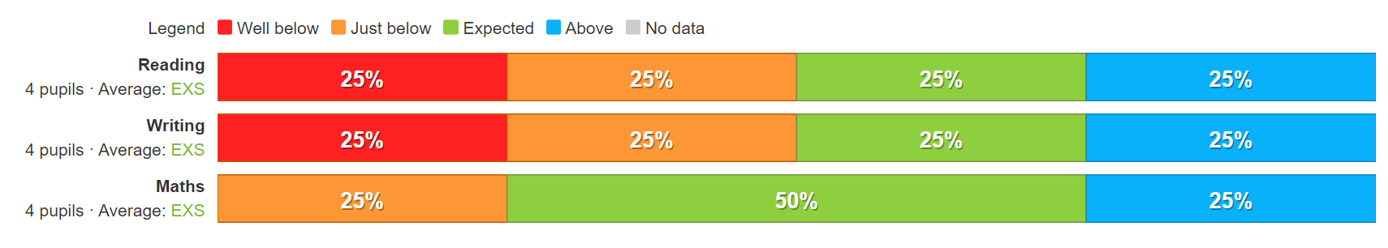
Y5
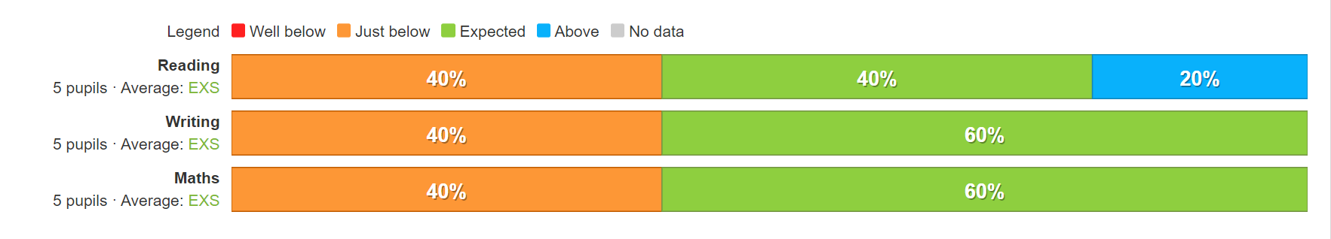
Y6
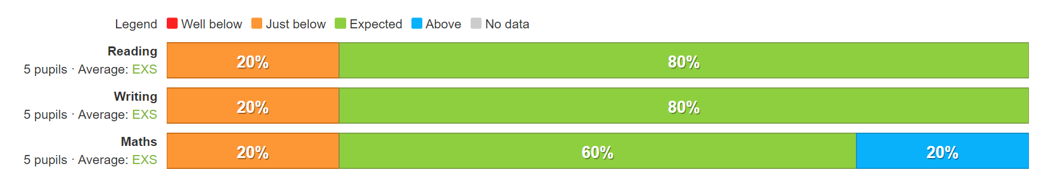
Main Findings from 21/22 outcomes
- We continue to see the impact of missed education but our strategy of 1:1 targeted interventions for our PP children is ensuring that gaps are closing
- As children move through the school the majority of disadvantage pupils are reaching age related expectation, although we do need to increase the numbers achieving greater depth
- Our most vulnerable learners ( including cared for children) are making good progress and leaving Galmpton exceptionally well prepared for their Secondary schools
- Where progress is slower, it is often because children have transferred to Galmpton and had limited time with us
- Our children with SEMH needs are responding well to the nurture/behaviour provisions we have in place
- Teachers are resolute and determined to make the difference for the most disadvantaged and understand the need to prioritise in lessons

