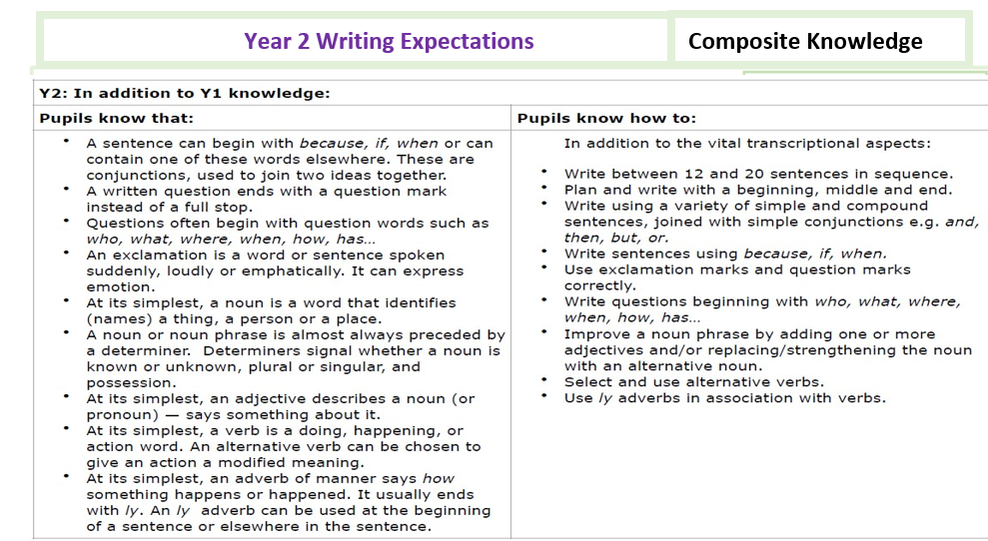
Component Knowledge
Letter Formation
Children know how to:
- sit correctly at a table, holding a pencil comfortably and correctly
- master the tripod grip of a pen/pencil.
- form lower case letters of the correct size, relative to one another.
- use spacing between words that reflects the size of the letters.
- use the diagonal and horizontal strokes needed to join letters.
- write capital letters and digits of the correct size, orientation and relationship to one another and to lower case letters.
Planning, drafting and Editing
- write narratives about personal experiences and those of others (real and fictional).
- plan what they are going to write about, including writing down ideas and/or key words and new vocabulary eg: bubble maps
- sequence what they want to say sentence by sentence.
- make simple additions, revisions and corrections to their own writing by evaluating their writing with the teacher and other pupils
- read to check that their writing makes sense and that the correct tense is used throughout with the help of an adult where necessary.
- check for errors in spelling, grammar and punctuation with an adult
Audience, Purpose and Structure
Children know how to:
- write for different purposes with an awareness of an
- increased amount of fiction and non-fiction structures.
- use new vocabulary from their reading, their discussions about it (one- to-one and as a whole class) and from their wider experiences.
- read aloud what they have written with appropriate intonation to make the meaning clear.
- Use similes within their writing, knowing how these can help create images and clarity for the reader

Sentence Structure (Including punctuation and grammar)
- use the present tense and the past tense mostly correctly and consistently.
- form sentences with different forms: statement, question, exclamation, command.
- use co-ordination (or/and/but).
- use some subordination (when/if/ that/because).
- use expanded noun phrases to describe and specify (e.g. the blue butterfly).
- use the full range of punctuation taught at key stage 1 mostly correctly including:
- capital letters, full stops, question marks and exclamation marks; commas to separate lists;
- Apostrophes to mark singular possession and contractions
Grammar Terminology
Recognise and use the terms:
- Noun
- Noun phrase
- Question
- Exclamation
- Command
- Suffix
- Adjective
- Verb
- Adverb
- Conjunction
- Consonant
- Vowel
Phonic & Whole word spelling
- To segment spoken words into phonemes and to represent these with graphemes, spelling many of these words correctly and making phonically-plausible attempts at others.
- To recognise new ways of spelling phonemes for which one or more spellings are already known and to learn some words with each spelling, including some common homophones (e.g. bare/ bear, blue/ blew, night/ knight).
- To apply further Y2 spelling rules and guidance*, which includes: the /dʒ/ sound spelt as ‘ge’ and’ dge’ (e.g. fudge, huge) or spelt as ‘g‘ or ‘j’ elsewhere in words (e.g. magic, adjust); the /n/ sound spelt ‘kn’ and ‘gn’ (e.g. knock, gnaw); the /r/ sound spelt ‘wr’ (e.g. write, written); the /l/ or /əl/ sound spelt –le (e.g. little, middle) or spelt –el (e.g. camel, tunnel) or spelt –al (e.g. metal, hospital) or spelt – il (e.g. fossil, nostril); the /aɪ/ sound spelt –y (e.g. cry, fly, July); adding –es to nouns and verbs ending in –y where the ‘y’ is changed to ‘i’ before the –es (e.g. flies, tries, carries); adding –ed, –ing, –er and –est to a root word ending in –y (e.g. skiing, replied) and exceptions to the rules; adding the endings –ing, –ed, –er, –est and – y to words ending in –e with a consonant before (including exceptions); adding –ing, –ed, –er, –est and –y to words of one syllable ending in a single consonant letter after a single vowel letter (including exceptions); the /ɔ:/ sound (or) spelt ‘a’ before ‘l’ and ’ll’ (e.g. ball, always); the /ʌ/ sound spelt ‘o’ (e.g. other, mother, brother); the /i:/ sound spelt –ey: the plural forms of these words are made by the addition of -s (e.g. donkeys, monkeys); the /ɒ/ sound spelt ‘a’ after ‘w’ and ‘qu’ (e.g. want, quantity, squash) the /ɜ:/ sound spelt ‘or’ after ‘w’ (e.g. word, work, worm); the /ɔ:/ sound spelt ‘ar’ after ‘w’ (e.g. warm, towards); the /ʒ/ sound spelt ‘s’ (e.g. television, usual)
Common Exception words
- To write some irregular common words.
- To spell days of the week, months of the year correctly.
- To spell all Y1 and Y2 common exception words correctly.
Prefixes and Suffixes
- To add suffixes to spell most words correctly in their writing, e.g. –ment, –ness, –ful, –less, –ly
Further Spelling conventions
- To spell more words with contracted forms, e.g. can’t, didn’t, hasn’t, couldn’t, it’s, I’ll.
- To learn the possessive singular apostrophe (e.g. the girl’s book).
- To write, from memory, simple sentences dictated by the teacher
Contexts for Writing
Autumn Term
Biography -Diverse authors RSE
Persuasive writing advert/brochure-Welcome to Torbay, Geography
No chronological report -Science – My amazing body
Narrative -linked to whole school enquiry, Christmas
Spring Term
Diary entry- History- The Queen’s Coronation
Science – non-chronological report
Art – Biography- Joan Miro
Writing weeks – Narrative-Flat Stanley
Summer Term
Information text -My locality- Geography
Letter/factual writing -linked to Dr Fischer- Science
Explanation text -History –Brunel
Report writing -RSHE
Poetry -Window by Jeannie Baker

