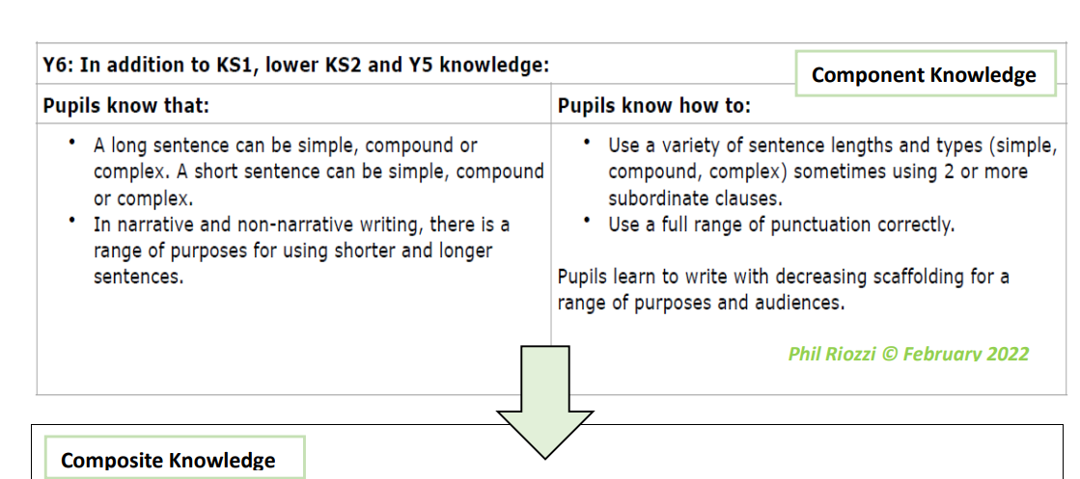
Year 6 Writing Expectations (In addition to KS1/KS2 and Y5 expectations)

Letter Formation
. In addition to KS1 and lower KS2 and Year 5 knowledge, children know how to:
- choose a standard of handwriting which is appropriate for a particular task, e.g. quick notes or a final handwritten, presented version.
- choose the writing implement which is best suited for a task
- Maintain legibility in joined handwriting when writing at speed
Planning, drafting and Editing
In addition to KS1 and lower KS2 and Year 5 knowledge, children know how to:
- note down and develop initial ideas, drawing on reading and research where necessary.
- use appropriate organisational and presentational devices to structure text and to guide the reader (e.g. headings, bullet points, underlining).
- use a wide range of devices to build cohesion within and across paragraphs.
- consistently proofread for spelling and punctuation errors.
- make changes to vocabulary, grammar and punctuation to enhance effects and clarify meaning. recognise how words are related by meaning as synonyms and antonyms and to use this knowledge to make improvements to their writing.

Audience, Purpose and Structure
In addition to KS1 and lower KS2 and Year 5 knowledge, children know how to:
- write effectively for a range of purposes and audiences, selecting the appropriate form and drawing independently on what they have read as models for their own writing (including literary language, characterisation, structure, etc.).
- distinguish between the language of speech and writing and to choose the appropriate level of formality.
- select vocabulary and grammatical structures that reflect what the writing requires (e.g. using contracted forms in dialogues in narrative; using passive verbs to affect how information is presented; using modal verbs to suggest degrees of possibility).
Sentence Structure (Including punctuation and grammar)
- ensure the consistent and correct use of tense throughout all pieces of writing, including the correct subject and verb agreement when using singular and plural.
- use the subjunctive form in formal writing.
- use the perfect form of verbs to mark relationships of time and cause.
- use the passive voice accurately within appropriate pieces.
- use question tags in informal writing (a very short clause at the end of a statement which changes the statement into a question. For example, in 'She said half price, didn't she? ', the words 'didn't she' are a question tag.”)
- use the full range of punctuation taught at key stage 2 correctly, including consistent and accurate use of semi colons, dashes, hyphens, colons, and when necessary, to use such punctuation
- precisely to enhance meaning and avoid ambiguity
Grammar Terminology
In addition to KS2 terminology, recognise and use the terms:
- Subject
- Object
- Active
- Passive
- Hyphen
- Colon
- Semi-colon
Phonic & Whole word spelling
- To spell words ending in -able and -ably (e.g. adorable/ adorably, applicable/ applicably, considerable/ considerably, tolerable/ tolerably).
- To spell words ending in -ible and -ibly (e.g. possible/possibly, horrible/horribly, terrible/ terribly, visible/ visibly, incredible/ incredibly, sensible/ sensibly).
- To spell words with a long /e/ sound spelt ‘ie’ or ‘ei’ after ‘c’ (e.g. deceive, conceive, receive, perceive, ceiling) and exceptions (e.g. protein, caffeine, seize).
- To spell words with endings which sound like /shuhl/ after a vowel letter using ‘cial’ (e.g. official, special, artificial).
- To spell words with endings which sound like /shuhl/ after a vowel letter using ‘tial’ (e.g. partial, confidential, essential).
Common Exception words
- To spell all of the Y5 and Y6 statutory spelling words correctly
Prefixes and Suffixes
- To use their knowledge of adjectives ending in -ant to spell nouns ending in -ance/-ancy (e.g. observant, observance, expectant, hesitant, hesitancy, tolerant, tolerance, substance).
- To use their knowledge of adjectives ending in -ent to spell nouns ending in -ence/-ency (e.g. innocent, innocence, decent, decency, frequent, frequency, confident, confidence, obedient, obedience, independent).
- To spell words by adding suffixes beginning with vowel letters to words ending in -fer (e.g. referring, referred, referral, preferring, preferred, transferring, transferred, reference, referee, preference, transference).
Further Spelling Conventions
- To spell homophones and near homophones that include nouns that end in -ce/-cy and verbs that end in -se/-sy (e.g. practice/ practise, licence/license, advice/ advise).
- To spell words that contain hyphens (e.g. co-ordinate, re-enter, co- operate, co-own).
Contexts (purpose) for Writing
Autumn Term
- Narrative – The Island
- Report/Persuasive Writing- Climate action justifications
- Non- chronological report – The Circulatory System
- Narrative – retelling, The Christmas Truce
- Narrative -depicting leadership & determination - The Little Ships
Spring Term
- Diary Writing – Voyage of HMS Beagle
- Narrative – detective story – Sherlock Holmes
- Explanation text – global trade
- Reflective Writing-Art
Summer Term
- Leaflet/poem for KS3 children about healthy lifestyle.
- Letter home from a sailor – The Georgians
- Letter writing – writing replies from a problem page.
- Character description – Macbeth

