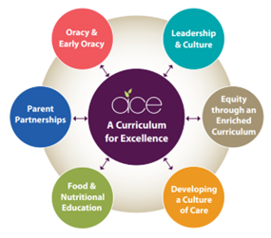
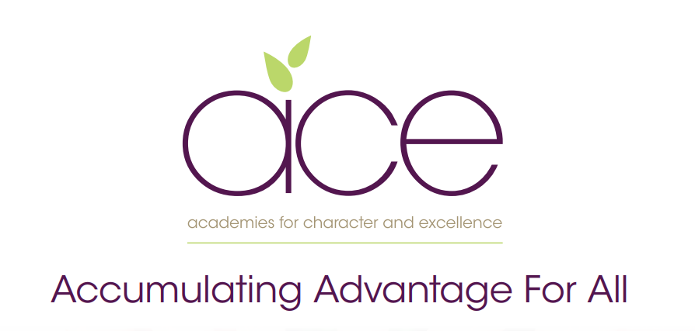

Galmpton Church of England school Pupil premium strategy statement
2023–2024

This statement details our school’s use of pupil premium (and recovery premium for the 2021 to 2022 academic year) funding to help improve the attainment of our disadvantaged pupils.
It outlines our pupil premium strategy, how we intend to spend the funding in this academic year and the effect that last year’s spending of pupil premium had within our school.

School overview

Detail | Data
School name | Galmpton C of E Primary
Number of pupils in school | 222
Proportion (%) of pupil premium eligible pupils | 14%
Academic year/years that our current pupil premium strategy plan covers (3 year plans are recommended) | 2021–2024
Date this statement was published | October 2023
Date on which it will be reviewed | November 2023
Statement authorised by | Governing body
Pupil premium lead | Tim Rutherford
Governor / Trustee lead | Katy Burns,

Funding overview

Detail |  | Amount
Pupil premium funding allocation this academic year | £34,920
Recovery premium funding allocation this academic year | -
Pupil premium funding carried forward from previous years (enter £0 if not applicable) | £0
Total budget for this academic year  If your school is an academy in a trust that pools this funding, state the amount available to your school this academic year | £34920

Part A: Pupil premium strategy plan

- See our Trust wide plan ‘Accumulating Advantage for all’
In a changing world we recognise the need to ensure that our Curriculum reflects how pupils are supported and encouraged to flourish in all aspects of their lives. Current research shows that the South West is one of the most challenging areas to grow up poor. We strongly believe that as a Trust, and through our Curriculum, we are able to narrow the disadvantaged gap, supporting all pupils.

Our aims for our disadvantaged pupils

- Our aim as a Trust is to ensure that all pupils accumulate advantage based on the high quality experience that we offer them through our Curriculum and enquiry based approach to learning.

- Our Curriculum is rich and ambitious and offers all pupils an equal opportunity to experience a range of outdoor lessons, take part in educational visits, theatre trips, hands-on days, expert visits and have the opportunity to explore a wide range of extra-curricular clubs.

- We believe that all pupils should have the opportunity to aspire to be the best version of themselves, therefore we provide pupils with the experiences that develop their love of learning and support them to acquire experiences as they move through their school lives, to make informed choices when deciding future decisions.

Statement of Intent

At the heart of our curriculum lie three core values: pursuit of academic excellence; the explicit teaching of learning to learn, which includes the development of metacognition; and crucially, character education. We believe that through our curriculum and core principles we can ensure that our very high expectations result in improved outcomes for disadvantaged pupils. This ensures all children will achieve and flourish whilst acquiring life longs skills that enable learners to overcome any barriers to learning and future successes.

Objectives for our disadvantaged Pupils

- We will ensure that the progress of our disadvantaged children will equal or exceed those who are not disadvantaged by implementing our strategy plan. The ACE curriculum plays a central and critical role in accumulating advantage for all pupils, including those that are presently or previously experiencing disadvantage.

- All disadvantaged pupils will be equipped, academically, socially, culturally and emotionally to continue to make progress at their Secondary schools and beyond. Our aim is to ensure that all children leaving our schools are successful learners, curious explorers and healthy thinkers.

Our current pupil premium plan focuses on the following goals (see ‘Accumulating advantage for all’ booklet for more detail)

Strong Leadership that drives:
- Equity through an enriched curriculum (including high quality, well researched and impactful interventions)
- A culture of high quality care
- Food and Nutritional Education
- Effective parent/carer partnerships
- Development of Early Oracy and ongoing oracy skills

Challenges

This details the key challenges to achievement that we have identified among our disadvantaged pupils.
Challenge number | Detail of challenge
1 | 50% of our disadvantaged children have poorer oracy skills on entry, including limited vocabulary, affecting their spoken language, comprehension and, later, their reading and writing skills. This also hampers accessing wider knowledge.
2 | 46% of children have social, emotional and mental health (SEMH) needs and at times these can negatively affect their learning.
3 | 30% of children can often lack resilience for learning and have more limited opportunities for learning outside of school.. These need to be provided by school and all opportunities to broaden horizons need to be maximised
4 | Some of our pupils struggle with written tasks and have negative attitudes towards sustained pieces of writing. Our ACE curriculum is allowing us to challenge these mindsets, although writing outcomes are lower across the school than other subjects
5 | For 37% of all disadvantaged pupils, mathematical concepts and reasoning skills are not as well developed as reading skills, poor mathematical fluency impacts on their ability to calculate, reason and problem solve.
6 | 25% of children on the register are our most vulnerable disadvantaged pupils have had previous trauma in their lives and this continues to impact on their lives.
7 | Greater Depth pupils who are eligible for Pupil Premium are not always making the same amount of progress as other greater depth pupils consistently in all year groups. Teachers spend a greater focus on the children who are working at ‘working towards the expected standard’ and are not 5 as skilled at challenging the highest attaining pupils or accelerating children’s progress towards greater depth.

Intended outcomes - see ‘Accumulating Advantage for all’

Intended outcome | Success criteria
- A Curriculum for Excellence  The ACE curriculum is ensuring QFT is making a difference for our disadvantaged pupils and progress measures show the gap between disadvantaged and others is closing | - As a result of careful and focused monitoring our PP pupils are becoming successful learners  - Journals reflect progress made in all three areas- metacognition, character education and academic excellence (see individual PP tracker)  - The progress of disadvantaged pupils is at least the same as the progress of non-disadvantaged pupils and no greater than a 10% difference by the end of KS2
- Oracy and Language Acquisition  All disadvantaged pupils have improved oracy skills and are increasingly able to communicate effectively | - Language link programme demonstrates improved language skills  - Oracy approach (across the curriculum) is evident in terms of key outcomes for pupils  - Our reading strategy is ensuring that by the time children reach Y6 all children are at least at the expected standard, including those on our SEND register  - Mathematical talk (fast five) and maths leader on going coaching sessions are improving fluency and mathematical understanding of concepts, this is impacting positively on outcomes  - PP children are read with daily, prioritised by class teachers and TA’s. Pre-teach of vocabulary is introduced to children and explained prior to provide more opportunities for children to be successful.  - Vocabulary is explicitly taught through quality first teaching and is planned for by class teachers in all subjects. All classes regularly using the ‘remote control’ cards’ to ensure retrieval of learnt vocabulary
- Enrichment opportunities are providing pupils with the skills and knowledge to become more successful learners | - Take up of ASCs is high and pupils are clearly gaining through these experiences  - All disadvantaged pupils attend residentials, which are partly funded by the school  - The school seeks meaningful opportunities to broaden pupils horizons eg visiting authors, musical workshops and innovative subject days at our local Secondary schools
- High quality care through SEMH support is ensuring excellent wellbeing and readiness for learning | - Pupil outcomes have improved in all areas (academically, socially, emotionally, culturally)  - Pastoral support is well matched to individual need  - The school will achieve Trauma informed accreditation ensuring all staff understand the importance of highly effective relational awareness and good mental health
- Food and Nutrition  Pupils and families have opportunities in school to participate in workshops and clubs to improve health through food and nutrition education | - All PP children are given opportunity to attend our cookery club  - Families invited to a ‘family bake’ session to celebrate the course and grow the club  - Children take part in food technology sessions where they develop their cooking skills  - PP children have access to high quality food throughout the school day, being hungry in school is never an issue.
- Parent/carer partnerships are strong and parents are increasingly able to support their children’s well being and learning | - Improve attendance of disadvantaged pupils to 95%  - Prioritise parent meetings and workshops for children with insufficient resources  - Continue to ensure all parents take part in learning enquiry outcomes where parents have the opportunity to share learning, journals and other engaging outcomes.

Activity in this academic year

Teaching (for example, CPD, recruitment and retention)

Budgeted cost: £20,000

Activity | Evidence that supports this approach | Challenge number(s) addressed
- Use of language link and other oracy strategies to develop communication skills in the Early Years and KS1 | Early Reading framework – Section 2: developing Talk and Appendix 2  EEF – Oral Language Interventions | 1,4
- Deliver impactful and bespoke nurture sessions that allow pupils to develop strategies around social skills, self regulation and self expression | EEF social and emotional learning  https://educationendowmentfoundation.org.uk/education-evidence/evidence-reviews/social-and-emotional-learning | 2
- Provide extended opportunities for pupils, ensuring all disadvantaged pupils have wider opportunities to take part in art, sports, music clubs | EEF social and emotional learning  https://educationendowmentfoundation.org.uk/education-evidence/evidence-reviews/social-and-emotional-learning | 3
- Continue to maintain standards in reading though our whole school reading approach  Smaller phonics groups for targeted RWI support. | EEF- Targeted Academic Support  EEF - Early Reading framework – Section 2: developing Talk and Appendix 2  https://educationendowmentfoundation.org.uk/education-evidence/evidence-reviews/reading-programmes  Implementing a systematic programme (ERF) Early Reading Framework – Section 5: Building a team of experts | 4
- Deliver pre teaching session and mathematical interventions to close gaps for lower attaining children | EEF -https://educationendowmentfoundation.org.uk/education-evidence/evidence-reviews/early-years-and-key-stage-1-mathematics-teaching | 5
- Develop wellbeing for pupils through the ‘one goal’ programme to ensure good mental health for all  Continue to provide pastoral/mental health support through the beach room club and afternoon nurture session | EEF – Embedding Formative Assessment  EEF – Metacognition  EEF- https://educationendowmentfoundation.org.uk/education-evidence/evidence-reviews/behaviour | 6

Targeted academic support (for example, tutoring, one-to-one support structured interventions)

Budgeted cost: £10,000

Activity | Evidence that supports this approach | Challenge number(s) addressed
1:1 phonics tutoring -Read, write Inc | EEF – one to one tutoring | 1,2
Additional reading support (including Fresh start -1 to 1) | Early Reading Framework – Section 5: Building a team of experts | 2
1:1 fluency intervention -Language link | EEF – improving literacy at KS2 | 2
Targeted support plans for individual PP pupils delivered by support staff. | EEF – Follow the Asses, Plan, Do, Review process | 1,2,3
Teachers prioritise pre-teaching in writing for most disadvantaged pupils (vocabulary checks, gathering ideas, plans for writing) | EEF – one to one tutoring | 1,2

Wider strategies (for example, related to attendance, behaviour, wellbeing)
Budgeted cost - £4920

Activity | Evidence that supports this approach | Challenge number(s) addressed
SENDco/Nurture support to support disadvantaged families with  Parenting advice, individual pupil support and referrals for escalated support . | EEF – parental engagement | 4,5,6
Nurture clubs provision and support for CFC pupils to ensure bespoke interventions and programmes for individual pupils | EEF – behaviour interventions | 3,4,6
Breakfast club when required to ensure a soft start regulation time. | EEF – Magic Breakfast Club | 4,6
25%-33% of funded residentials and other trips and visits | EEF – wider opportunities | 5,6
SENDco/Nurture support to support disadvantaged families with  Parenting advice, individual pupil support and referrals for escalated support . | EEF – parental engagement | 4,5,6

Total budgeted cost: £34920

Part B: Review of outcomes in the previous academic year

Findings relating to our disadvantaged pupils were as follows:

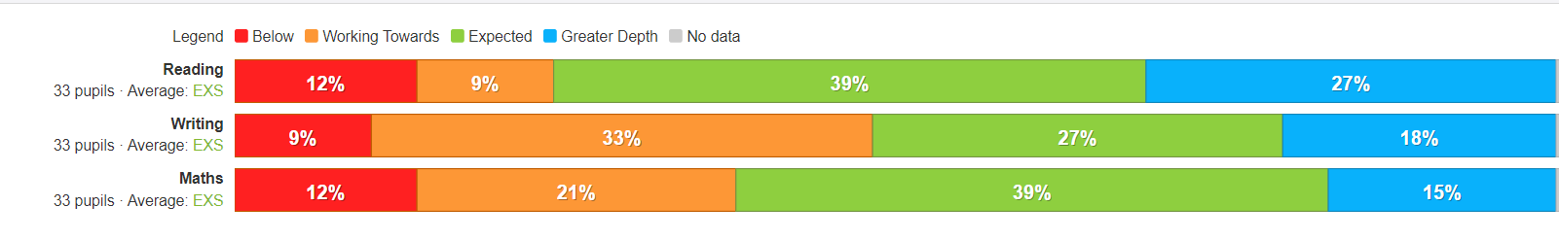
2022/2023 Whole school outcomes for Disadvantaged pupils

2022/2023 outcomes for by year group

EYFS
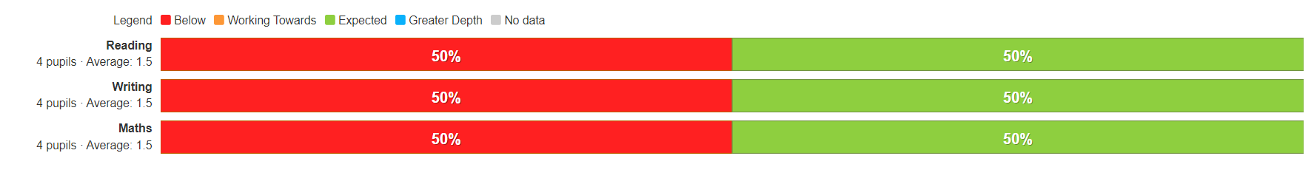
Y1
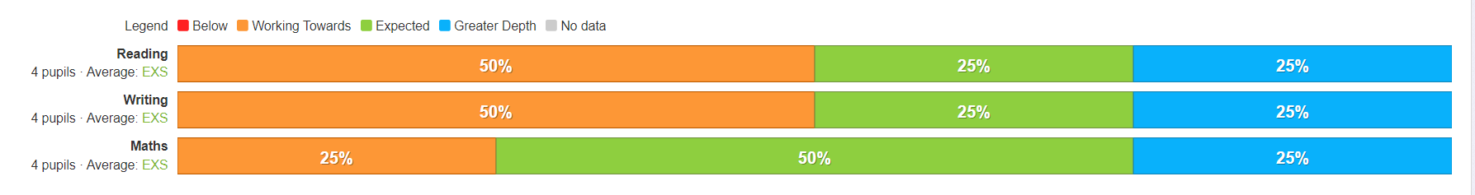

Y2
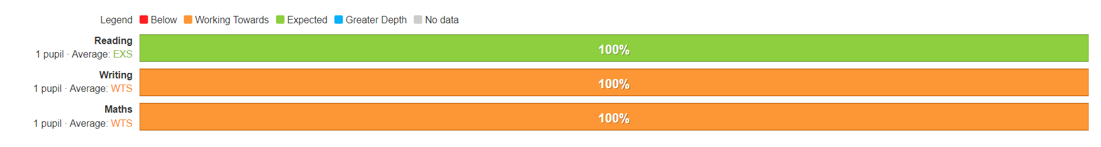
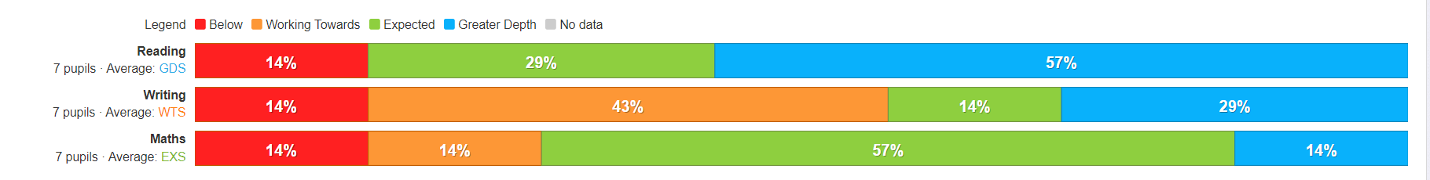
Y3

Y4

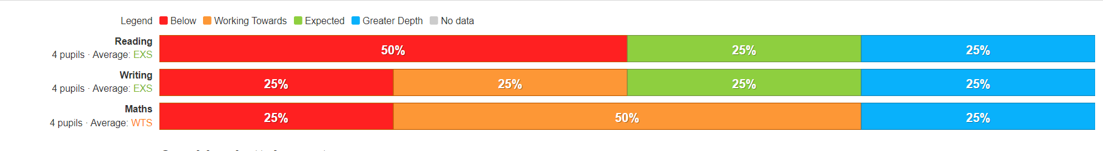
Y5

Y6

Y6
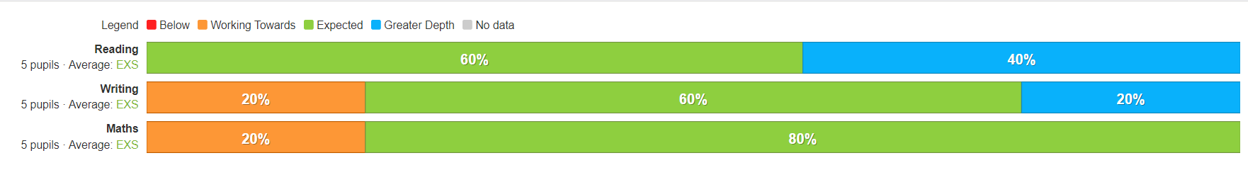
Main Findings

Intended outcome | Success criteria | 21/22 | 22/23 | 23/24
The ACE curriculum is ensuring QFT is making a difference for our disadvantaged pupils and progress measures show the gap between disadvantaged and others is closing | As a result of careful and focused monitoring our pupils are becoming successful learners (see ACE SL outcomes)
 | Journals reflect progress made in all three areas- metacognition, character education and academic excellence (see individual PP tracker)
 | The progress of disadvantaged pupils is at least the same as the progress of non-disadvantaged pupils and no greater than a 10% difference by the end of KS2 for reading
Oracy  All disadvantaged pupils have improved oracy skills and are increasingly able to communicate effectively | Mathematical talk (fast five) and maths leader ongoing coaching sessions are improving fluency and mathematical understanding of concepts, this is impacting positively on outcomes.
 | Our reading strategy is ensuring that by the time children reach Y6 all children are at least at the expected standard
 | Pre-teach of vocabulary is introduced to children and explained prior to lesson, this provides more opportunities for children to be successful.in the lesson
 | Vocabulary is explicitly taught through quality first teaching and is planned for by class teachers in all subjects. All classes regularly using the ‘remote control’ cards’ to ensure retrieval of learnt vocabulary
 | Our oracy approach (across the curriculum) is evident in terms of key outcomes for pupils.
 | Language link programme demonstrates improved language skills for all pupils taking part in interventions
Enrichment opportunities are providing pupils with the skills and knowledge to become more successful learners | Take up of ASCs is high and pupils are clearly gaining through these experiences
 | The school seeks meaningful opportunities to broaden pupils horizons eg visiting authors, musical workshops and innovative subject days at our local Secondary schools. This is raising aspirations for children and providing enriching experiences
 | All disadvantaged pupils attend residentials, which are partly funded by the school. Pupils participate in a wider range of sports, team games and develop ACE character traits.
High quality care through SEMH support is ensuring excellent wellbeing and readiness for learning | Pupil outcomes have improved in all areas (academically, socially, emotionally, culturally) as a result of our nurture support and bespoke interventions
 | Pastoral support is well matched to individual need. The school has achieved Trauma informed accreditation ensuring all staff understand the importance of highly effective relational awareness and good mental health for all
 | Wellbeing warriors are carefully selected so that their training and support of other learners positively impacts on their own well being
Food and Nutrition  Pupils and families have opportunities in school to participate in workshops and clubs to improve health through food and nutrition education | All children in receipt of PP are given the opportunity to attend our cookery club. Families invited to a ‘family bake’ session to celebrate the course and grow the club.
 | Children take part in food technology sessions where they develop their cooking skills. Outcomes are shared with families and healthier eating options are explored and adopted by families.
 | All children have access to high quality food throughout the school day, being hungry in school is never an issue.
Parent/carer partnerships are strong and parents are increasingly able to support their children’s well being and learning | Improve attendance of disadvantaged pupils to 95%.
 | Prioritise parent meetings and workshops for children with insufficient resources. Eg phonics workshops to ensure improved engagement with home learning
 | Continue to ensure all parents take part in learning enquiry outcomes where parents have the opportunity to share learning, journals and other engaging outcomes
Intended outcome | Success criteria | RAG | RAG | RAG

