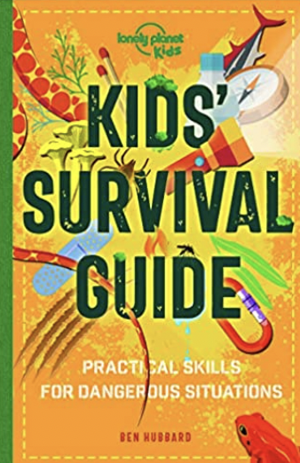

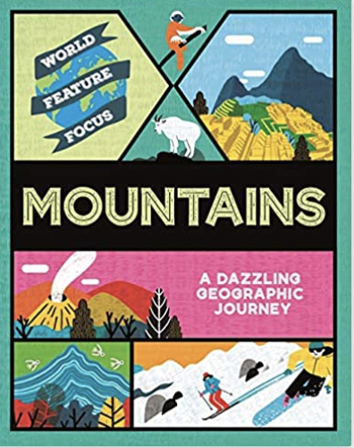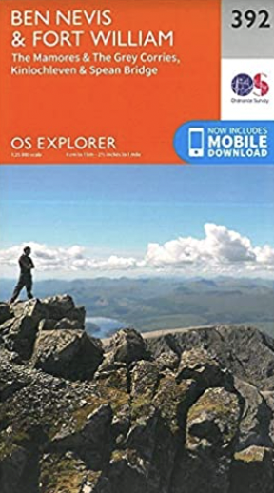

**What would it be like to explore the UK’s tallest mountain?**

**Being a Geographer**

**Developing my Character**

**People**

understand that populations have an environmental impact including congestion and pollution.

**Place**

understand that different counties make up a region

**Enquiry**

understand that extracting information helps to make comparisons..

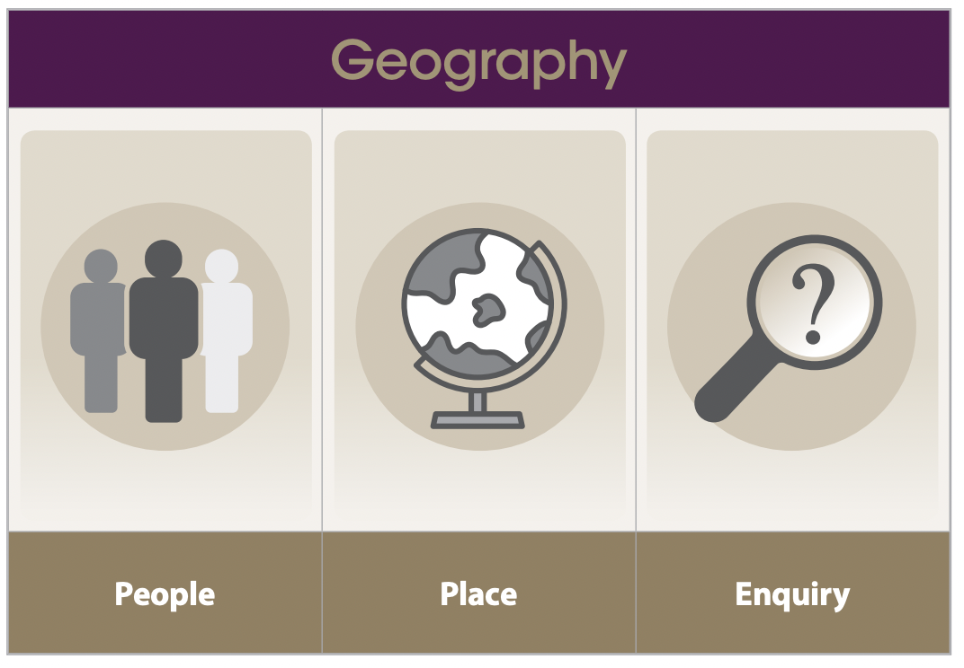

**

**

**Outcome – I will create a survival guide for visiting Ben Nevis.**

**Developing as a Learner**