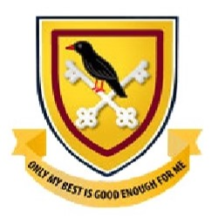
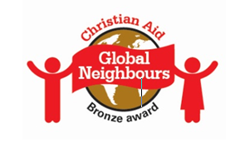
News Release
25TH June 2020
Galmpton School’s Work Tackling Global Poverty Recognised with Christian Aid Award
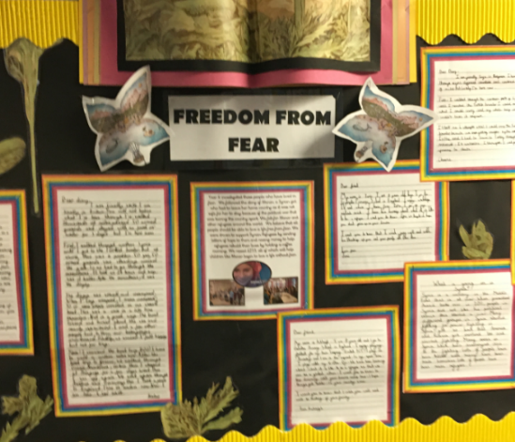
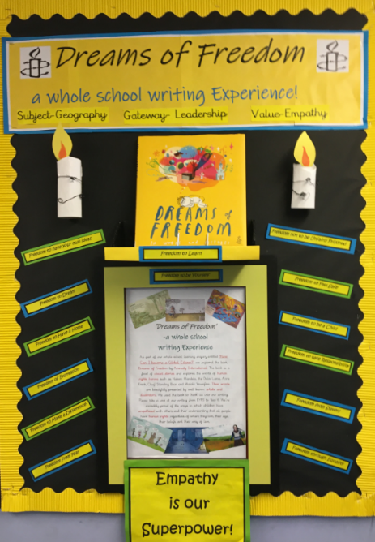
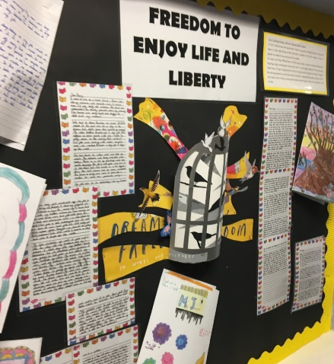

Pupils at Galmpton Primary have been presented with a Bronze Award from Christian Aid’s Global Neighbours Scheme for their global citizenship work. The whole school used Amnesty International’s Book ‘Dreams of Freedom’ to explore the UN charter on the rights of the child.
From writing to the government about child labour, to raising over £200 for Christian Aid’s refugee campaign and working with local charities, pupils and staff at Galmpton Primary School have been working hard to take their place as global citizens.
Galmpton Church of England Primary School in Torbay has achieved Bronze Award status in Christian Aid’s Global Neighbours scheme in recognition of its wide-ranging steps to love their global neighbour.
The accreditation scheme celebrates schools that are helping pupils learn about global poverty and the Christian responsibility to tackle it, as well as giving them the tools to play a confident part in creating a fairer world.
Headteacher and Global Neighbours lead, Mrs Burns said: “We are thrilled to be recognised for the work we have done as a whole school community to raise awareness of the extreme inequalities across our globe and perhaps more importantly, the steps we can take to address these. The pupils learnt about global issues and explored the question of what it means to be a global citizen. This led to working with volunteers from the Peru’s Children’s Trust to learn about the needs and challenges of orphaned children in Peru. Our pupils have learnt extensively about the Syrian refugee crisis and shared their thoughts with their parents through learning journals to aid parents in understanding the complex issues refugees endure. The children held a information sharing coffee morning with parents to raise awareness of the refugee crisis and to fundraise for those who have been forced to leave their homes. In addition, our pupils wrote letters imagining they were refugees to further their understanding of values such as compassion, integrity and empathy. We took part in Christian Aid’s scheme because it gives us a practical way of living out our school value of taking responsibility.
“Our world is increasingly connected and our hope is for our children to grow as responsible global citizens who care about issues such as the environment and access to healthcare. The children have especially enjoyed the Dreams of Freedom book, exploring the art work of a range of well known illustrators as well as exploring the inspiring words from Global ambassadors such as Malala Yousafzai, Nelson Mandela, Anne Frank and the Dalai Lama .
Caroline Weir, Education Coordinator at Christian Aid, said: “The Global Neighbours Scheme was launched in partnership with the Church of England’s Education Office with a vision of helping young people understand more about the inequalities in this world and helping them to become courageous advocates for those who have no voice.
It’s wonderful to see how staff and pupils at Galmpton have taken this to heart and are seeking to tackle injustice.
“Notes to Editors:
1. Christian Aid works in some of the world's poorest communities in around 40 countries at any one time. We act where there is great need, regardless of religion, helping people to live a full life, free from poverty. We provide urgent, practical and effective assistance in tackling the root causes of poverty as well as its effects.
2. Christian Aid’s core belief is that the world can and must be changed so that poverty is ended: this is what we stand for. Everything we do is about ending poverty and injustice: swiftly, effectively, sustainably. Our strategy document Partnership for Change explains how we set about this task.
3. Christian Aid is a member of the ACT Alliance, a global coalition of more than 130 churches and church-related organisations that work together in humanitarian assistance, advocacy and development.
4. For more about Christian Aid’s work, visit www.christianaid.org.uk

