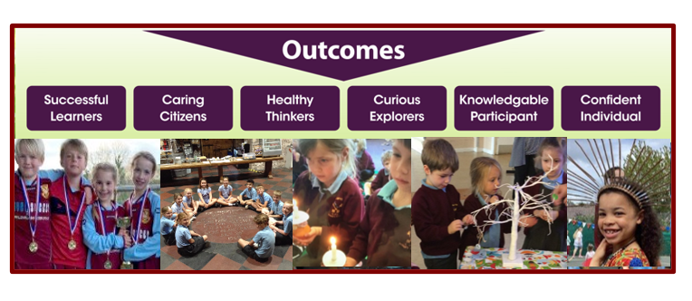

**Community Partnerships**

Christmas cards for the local residential homes -**Autumn 2**

Open gardens joint village art project - **Summer 2**

Card making art Project at the Railway -**Summer 2**

**Visitors and Expert Leads**

RSHE: Joanne Isemede -keynote speaker on Nigerian culture – **Autumn 1**

Art workshop with Mrs Partridge - **Spring 2**

Art workshop with Mrs Partridge - **Spring 2**

**Visits and Trips**

Bus trip around Torbay – **Autumn 1**

Coronation Meadow Tree planting – **Spring 2**

Greenway House – **Spring 2**

Paignton zoo visit **- Summer 1**

Broadsands Viaduct visit **- Summer 2**

**Cross Trust and other school events**

ACE Olympics **– Summer 2**

Sports day- **Summer 2**

ACE music event- **Summer 2**

**Church and mission community Projects**

Joint Parish/school service-**Summer 2**

Harvest Brixham food bank appeal **Autumn 1**

Shoe Box appeal – **Autumn 2** Christmas carol singing/church services

**Character Education Opportunities**

Christmas Nativity Extravaganza at Beverly Park - **Autumn 2**

Summer fayre fund raising class project – **Summer 2**

Shared community World Book dayevent **- Spring 2**

**Diversity**

RSHE: Joanne Isemede -keynote speaker on Nigerian culture – **Autumn 1**

Twisted tales outcome -presentation to parents-**Spring 2**

**Personal Development and Enrichment Opportunities Year 2**

**Keeping Safe**

Fire Safety Talk - **Spring 1**

First Aid day course-

**Summer 2**