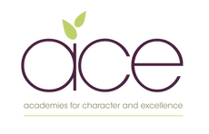
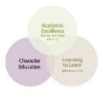
Galmpton C of E Primary Long Term Planner whole school 2025/2026

Autumn 1 |  |  | Autumn 2 |  |  | Spring 1 |  |  | Spring 2 |  |  | Summer 1 |  |  | Summer 2
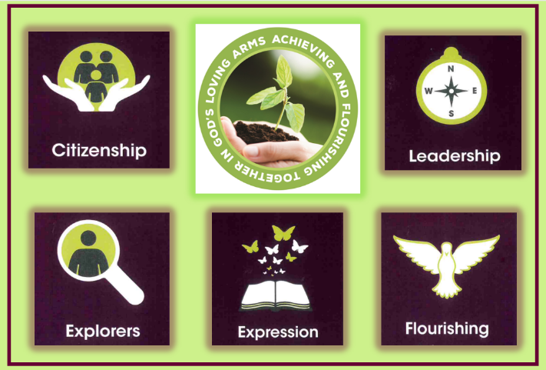  Citizenship |  |  |   Exploration |  |  | 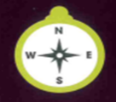  Leadership |  |  |   Expression |  |  | 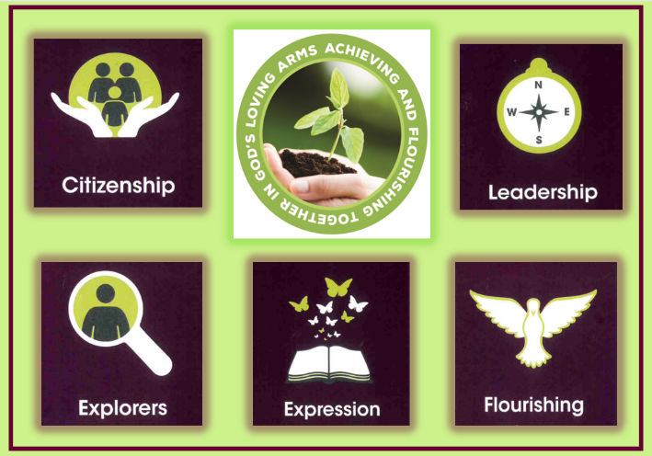  Flourishing |  |  |   Citizenship
Year group and Whole school Learning Experiences
Metacognitive strand  Independence |  |  | Metacognitive strand  Creativity |  |  | Metacognitive strand  Collaboration |  |  | Metacognitive strand  Independence |  |  | Metacognitive strand  Creativity |  |  | Metacognitive strand  Collaboration
Whole school enquiry-Autumn1  Why is Legacy Important?  7 weeks |  |  | Whole school enquiry-Autumn 2  What will my gifts be this Christmas?  7 weeks |  |  | Whole school enquiry-Spring 1-  - What does a diverse Community look like?  - How am I achieving and flourishing? (assessment midpoint review)  5 weeks 4 days |  |  | Whole school enquiries  Spring 2-  - How is land used by the local community?  - Why is Easter so important for Christians?  5 weeks 4 days |  |  | Whole school enquiries  Summer 1- What is my role in this changing world?  4 weeks 5 days |  |  | Whole school enquiries  Summer 2-  - How can I best serve my community?  - What does it mean to grow and change?  7 weeks
Writing | History | DT | Science | Narrative | Art | PSHE | History | Self-review  days  Self-assessment and conferencing days-my report | Geography | Science | RWE | Science |  | Art | Geography |  | Narrative | RSE | Self-review  days  Self-assessment and conferencing days-my report | DT
Agatha Christie-  Narrative | Romans/Boudica | Making something that’s been tested | Materials and water | Christmas writing | Drawing and Painting  Winter scene | Difference and diversity | Stone Age |  | Region of the UK  From source to sea, what is the journey of the river Dart? | Rocks & Fossils | The Easter story  (2 days) | Living Things (plants)  How can we ensure pollinators flourish in our gardens? |  | Printing | Contrasting region of the UK |  | Class choice | My body |  | Cooking-serving my community through a food learning experience
Outcome and key dates
- 19th September – whole school Agatha Christie exhibition/festival  - DT product |  |  | - Science information text  - 17th December -Christmas gift/art gallery for the community, class workshops and artist talks  - Christmas writing  - Christmas service/nativity Wednesday 10th December. |  |  | - whole school book our beautiful diverse world?  - Science explanatory text illustrated  - Mid-year report card written by pupils – 12th/13th February |  |  | - Infographic page detailing countries of the UK  - Completed pieces prepared for open gardens  - Easter service -performance/service  for the community - 2nd April |  |  | - Open gardens event, tour guides and art -7th June exhibition for community  - Class book detailing the GFOL events |  |  | - Extended written piece of writing  - Labelled body map  - Completed end of year report- 29th/30th June  - Contribution to a local community food/cooking event WB 13th July
Writing Genre
Biography / Playscript | Brochure writing/  persuasive | Reflective writing | Explanation | Narrative | Descriptive writing | Poetry | Debate: Is Kents Cavern a tourist attraction or historical site? |  | Non chron report | Scientific investigation | Story | Letter | Fictional writing |  |  | Story writing/adventure |  | Labelling | Reflective writing |  | Instructions
Teaching of Other Subjects

Religion and Worldviews – a core subject also taught weekly Music- weekly lessons using the Kapow programme MFL- weekly lessons using the Kapow programme
PE/Games including swimming in KS2 taught weekly

