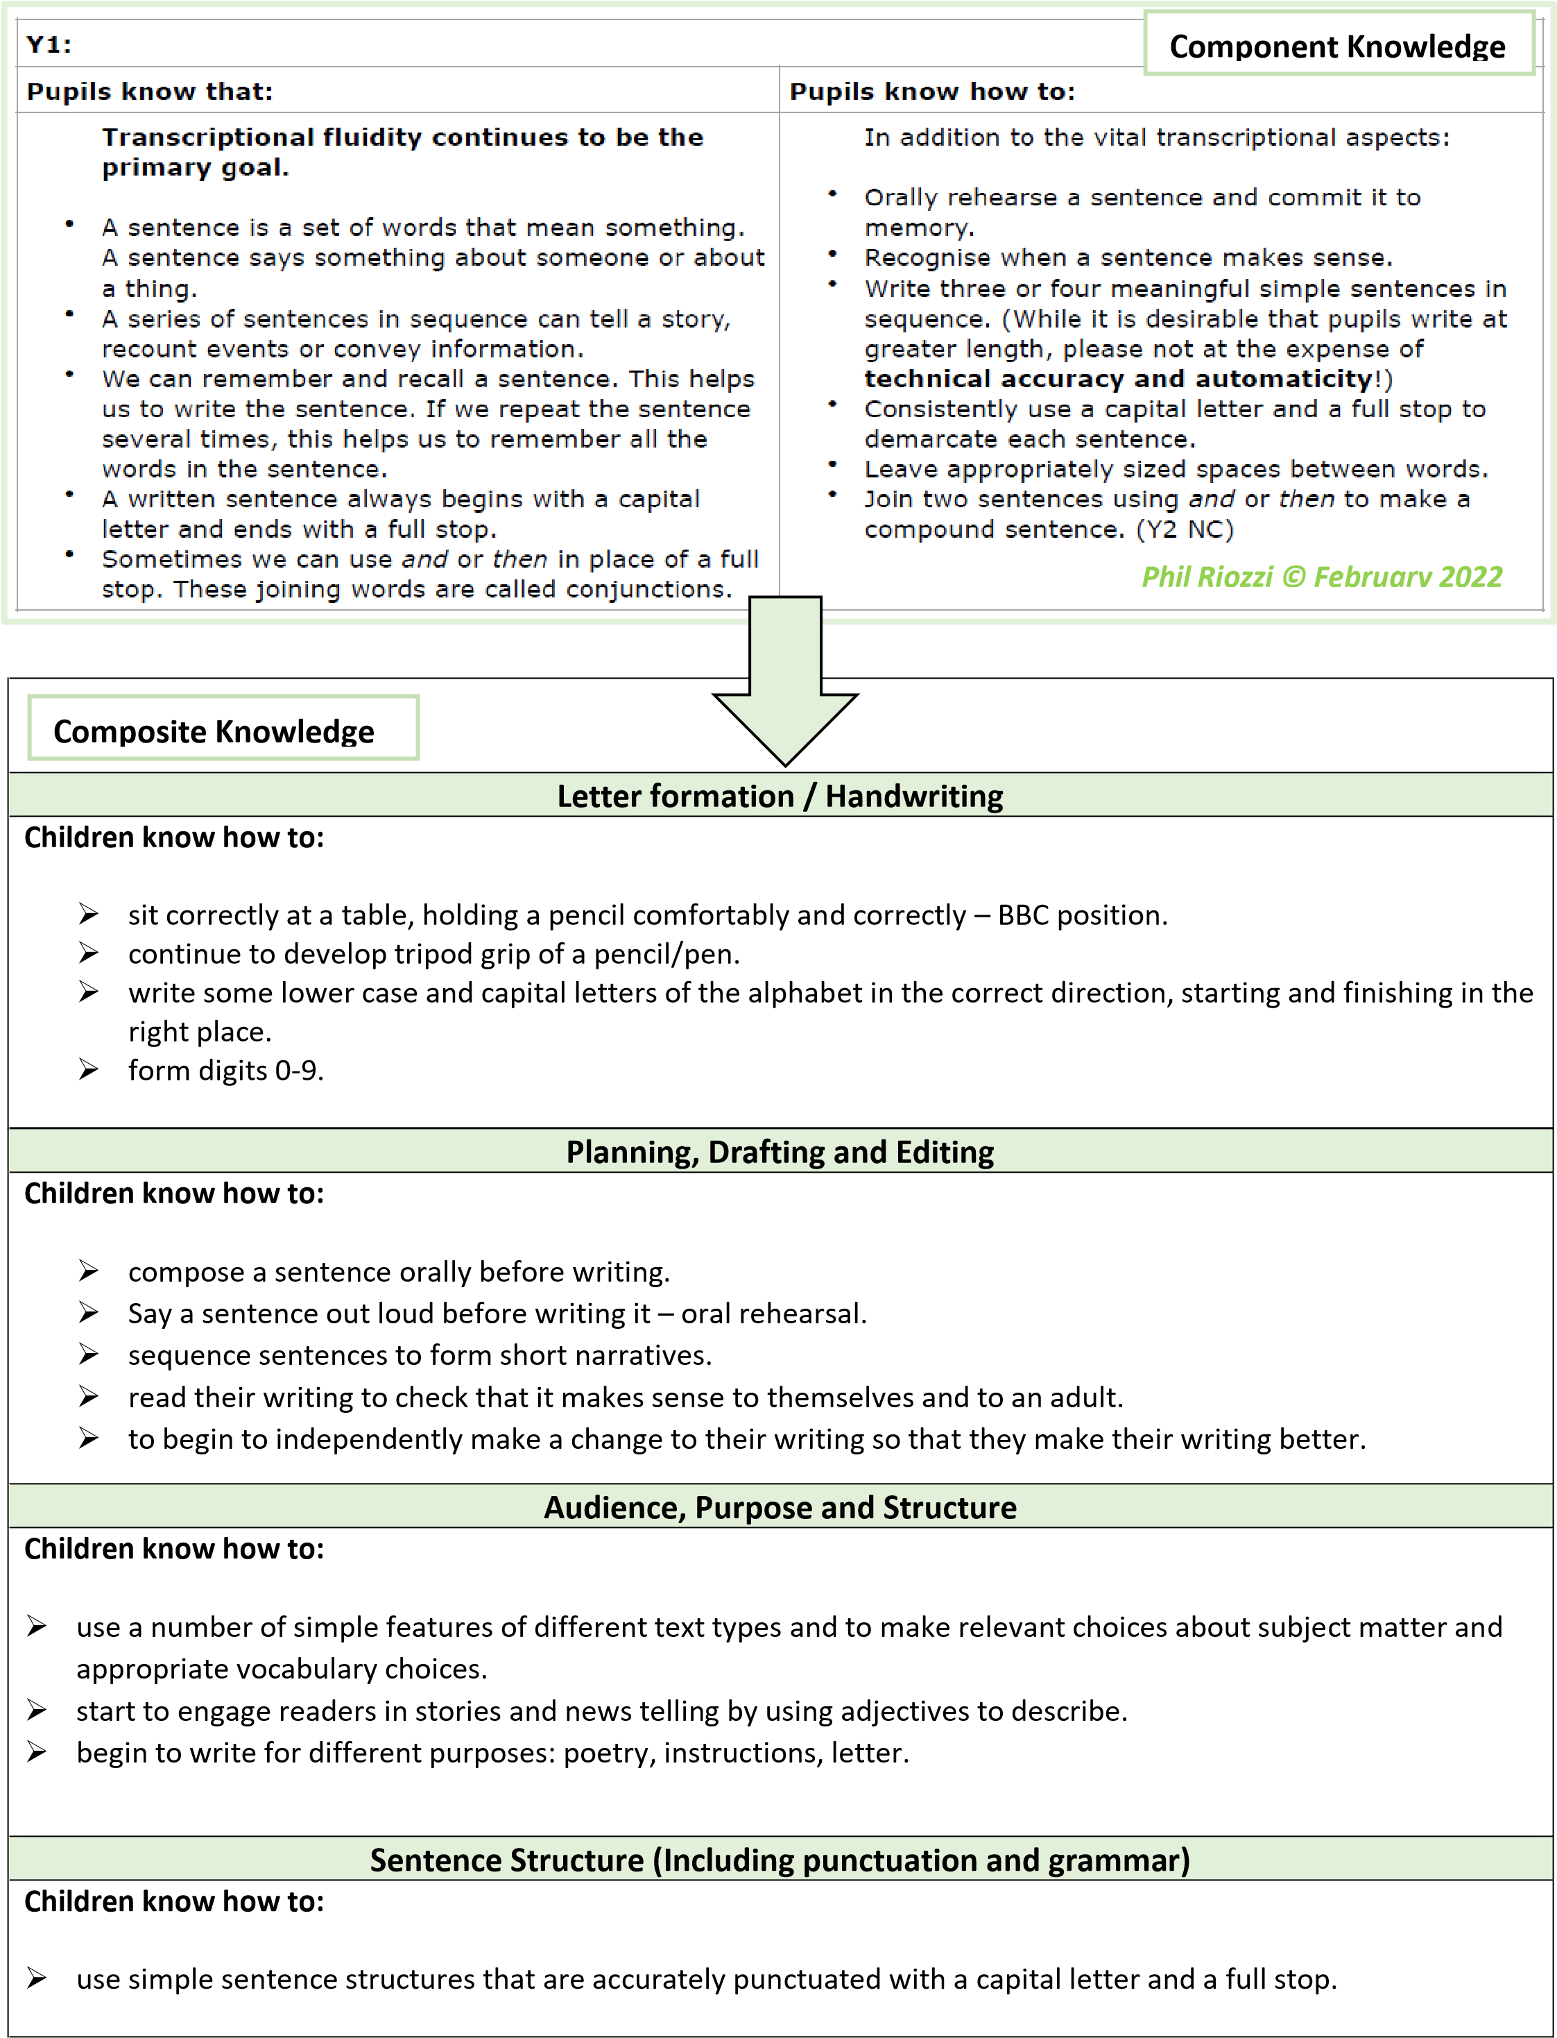
Year 1 Writing Expectations
- use simple conjunctions (and, but) to link ideas in sentences.
- form simple compound sentences.
- use capital letters for names, places, the days of the week and the personal pronoun ‘I’. ➢ use finger spaces.
- use full stops to end sentences.
- use question marks and exclamation marks.

Grammar Terminology
Recognise and use the terms:
- Letter
- Capital letter
- Word
- Singular noun
- Plural noun
- Sentence
- Full stop
- Question mark
- Exclamation mark
Phonics & spelling Rules
- To know all letters of the alphabet and the sounds which they most commonly represent.
- To recognise consonant digraphs which have been taught and the sounds which they represent.
- To recognise vowel digraphs which have been taught and the sounds which they represent.
- To recognise words with adjacent consonants.
- To accurately spell most words containing the 40+ previously taught phonemes and GPCs.
- To spell some words in a phonically plausible way, even if sometimes incorrect.
- To apply Y1 spelling rules and guidance*, which includes: the sounds /f/, /l/, /s/, /z/ and /k/ spelt ‘ff’, ‘ll’, ‘ss’, ‘zz’ and ‘ck’ and exceptions; the /ŋ/ sound spelt ‘n’ before ‘k’ (e.g. bank, think); dividing words into syllables (e.g. rabbit, carrot); the /tʃ/ sound is usually spelt as ‘tch’ and exceptions; the /v/ sound at the end of words where the letter ‘e’ usually needs to be added (e.g. have, live); adding -s and -es to words (plural of nouns and the third person singular of verbs); adding the endings –ing, –ed and –er to verbs where no change is needed to the root wood (e.g. buzzer, jumping); adding –er and –est to adjectives where no change is needed to the root word (e.g. fresher, grandest); spelling words with the vowel digraphs and trigraphs: - ‘ai’ and ‘oi’ (e.g. rain, wait, train, point, soil); ‘oy’ and ‘ay’ (e.g. day, toy, enjoy, annoy); a–e, e–e, i–e, o–e and u– e (e.g. made, theme, ride, woke, tune); ‘ar’ (e.g. car, park); ‘ee’ (e.g. green, week); ‘ea’ (e.g. sea, dream); ‘ea’ (e.g. meant, bread); ‘er’ stressed sound (e.g. her, person); ‘er’ unstressed schwa sound (e.g. better, under); ‘ir’ (e.g. girl, first, third); ‘ur’ (e.g. turn, church); ‘oo’ (e.g. food, soon); ‘oo’ (e.g. book, good); ‘oa’ (e.g. road, coach); ‘oe’ (e.g. toe, goes); ‘ou’ (e.g. loud, sound); ‘ow’ (e.g. brown, down); ‘ow’ (e.g. own, show); ‘ue’ (e.g. true, rescue, Tuesday); ‘ew’ (e.g. new, threw); ‘ie’ (e.g. lie, dried); ‘ie’ (e.g. chief, field); ‘igh’ (e.g. bright, right); ‘or’ (e.g. short, morning); ‘ore’ (e.g. before, shore); ‘aw’ (e.g. yawn, crawl); ‘au’ (e.g. author, haunt); ‘air’ (e.g. hair, chair); ‘ear’ (e.g. beard, near, year); ‘ear’ (e.g. bear, pear, wear); ‘are’ (e.g. bare, dare, scared); spelling words ending with –y (e.g. funny, party, family); spelling new consonants ‘ph’ and ‘wh’ (e.g. dolphin, alphabet, wheel, while); using ‘k’ for the /k/ sound (e.g. sketch, kit, skin).
Common Exception words
- To spell most common exception words correctly.
- To spell days of the week correctly
Prefixes and Suffixes
- To use -s and -es to form regular plurals correctly.
- To use the prefix ‘un-’ accurately.
- To successfully add the suffixes –ing, –ed, –er and –est to root words where no change is needed in the spelling of the root words (e.g. helped, quickest).
Other Spelling conventions
- To spell simple compound words (e.g. dustbin, football).
- To read words that they have spelt.
- To take part in the process of segmenting spoken words into phonemes before choosing graphemes to represent those

Contexts for Writing
Autumn Term
- Narrative – Lubna and the Pebble
- Explanation text – Geography - maps
- Information text – materials/science
- Science report - Materials
- Narrative – The Nativity
Spring Term
- Interview with the Queen/King - History
- Information text – Science- plants
- Poetry – linked to art and emotions
- Narrative – Wild Tiger
Summer Term
- Recount – fieldwork Geography
- Descriptive writing – Science - seasons
- Diary - Francis Drake
- Descriptive Narrative - sculpture

