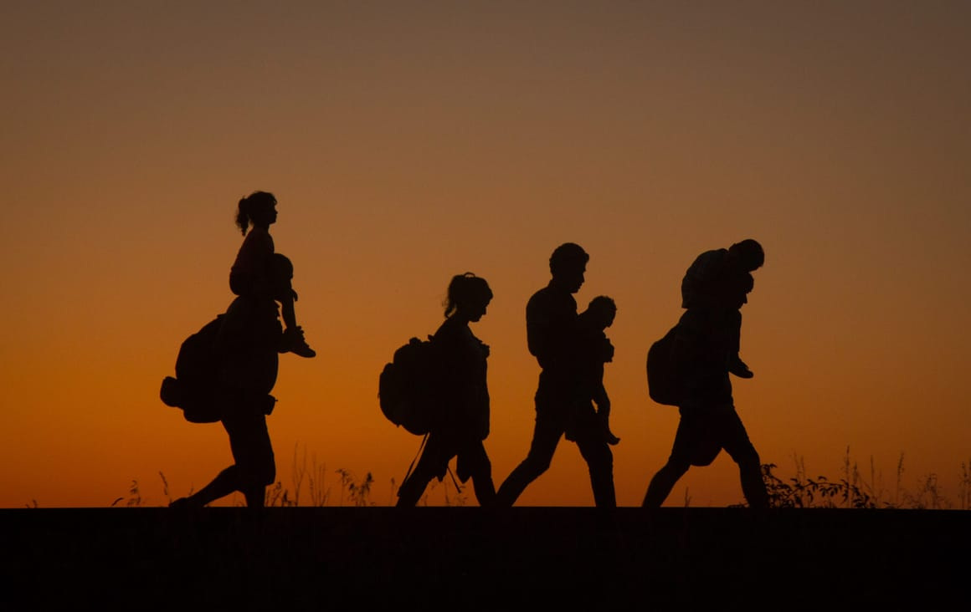
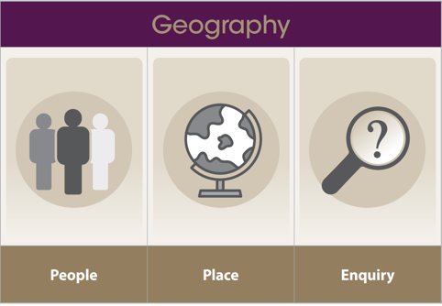
What does it mean to be forced to flee?
Geography learning organiser Year 5

Vocabulary
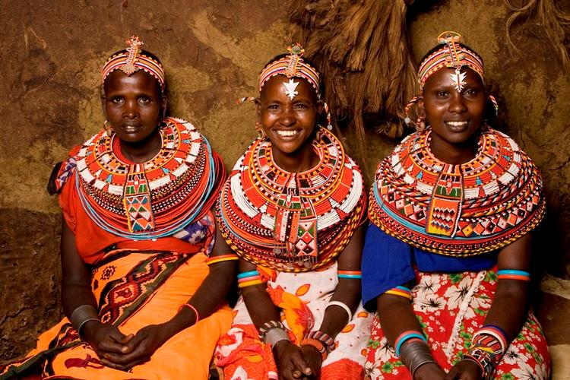
Immigrant - Someone who joins a new country.
Emigrant - Someone who leaves their home county.
Refugee - A person who has been forced to leave their country to escape war, persecution, or natural disaster and has been granted access to a new country.
Asylum seeker - Someone who has applied to a county to become a refugee there.
Political - To do with the government, laws, leaders and how they affect the population.
Social - To do with people, relationships, culture, and communities.
Environmental - Natural factors that are out of human control.
Case study - An example that can be researched.
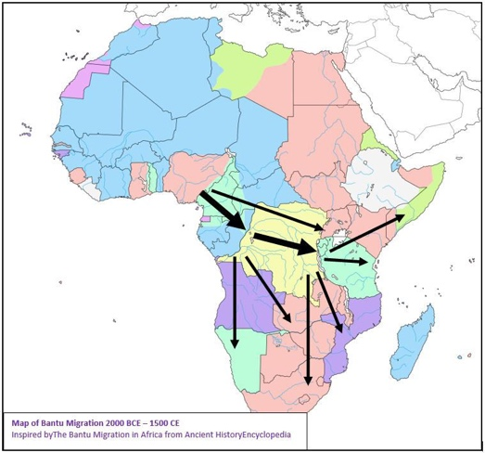
Longitude - Imaginary lines showing east-west locations.
Latitude - Imaginary lines showing north-south locations.
Prime meridian - Central line dividing hemispheres
Natural resources - Useful materials from Earth's environment
Trade links - Connections for exchanging goods/services
Economic – Relating to money, jobs, and trading.

End of enquiry learning

To use a Mercator map
To use latitude and longitude to locate countries.
To use four figure grid references
To explain the difficulties that living in an area can cause
To summarise the advantages and disadvantages of migration and immigrating.
To explain why populations move.
To explain why areas are different in terms of their natural resources and physical features.
Present and organise my findings in a structured way.
Understand how countries are connected and interdependent
Know that countries do not always collaborate
Understand why people settle in certain places and the reasons for this (social, economic, political, and environmental)
Understand why some countries are more populated
Understand why some people have more freedom to travel around the world than others.

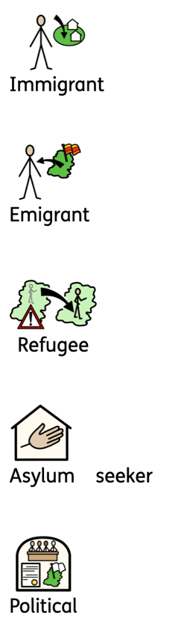
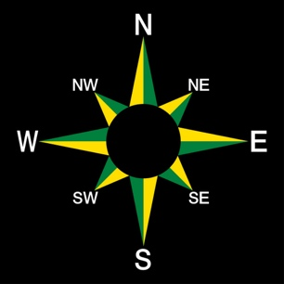
What does it mean to be forced to flee?
Geography learning organiser Year 5

Vocabulary
Immigrant - Someone who joins a new country.
Emigrant - Someone who leaves their home county.
Refugee - A person who has been forced to leave their country to escape war, or natural disasters and has been granted access to a new country.
Asylum seeker - Someone who has applied to a county to become a refugee there.
Political - To do with the government, laws, leaders and how they affect the population.
Social - To do with people, relationships, culture, and communities.
Environmental - Natural factors
Case study - An example
Longitude - Imaginary lines showing
east-west locations.
Latitude - Imaginary lines showing
north-south locations.
Prime meridian - Central line dividing hemispheres
Natural resources - Useful materials from Earth's environment
Trade links - Connections for exchanging goods/services
Economic – Relating to money, jobs, and trading.

End of enquiry learning

To use a Mercator map
To use latitude and longitude to locate countries.
To use four figure grid references
To explain the difficulties that living in an area can cause
To summarise the advantages and disadvantages of migration and immigrating.
To explain why populations move.
To explain why areas are different (natural resources and physical features)
Present and organise my work in a clear way.
Understand how countries are connected and interdependent (collaborate) and that not all countries do.
Understand why people settle in certain places and the reasons for this.
Understand why some countries are more populated
Understand that some people have more freedom to travel around the world than others.
